# Notes for Calculus Lifesaver

**CHAPTER 1 Functions, Graphs, and Lines**



1. Functions

* polynomials 多项式; exponentials 指数; logarithms 对数; trigonometric 三角法的, 三角学的 sphere;quadratics;
* [**R**](https://en.wikipedia.org/wiki/Real_number): the set of all real numbers: The real numbers include all the rational numbers **[Q]**, such as the integer **[Z]**[N] −5 and the fraction 4/3, and all the irrational numbers, such as √2 (1.41421356..., the square root of 2, an irrational algebraic number). Included within the irrationals are the transcendental numbers, such as π (3.14159265...). See **Figure 1**.

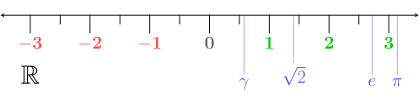

Figure 1. **[R]**: Real number; **[Q]**: rational numbers; **[Z]**: integers; **[N]**: natural numbers

1. Interval notation

* {*x*: 2≤ *x* < 5} = [2, 5)

1. Finding the domain (like *x*)

* The denominator of a fraction can't be zero. =! 0
* You can't take the square root (or fourth root, sixth root, and so on) of a negative number. ≥ 0
* You can't take the logarithm of a negative number or of 0. > 0
* (-8, 13] \ {2}: the domain is the set (-8; 13] except for the number 2

1. Finding the range using the graph

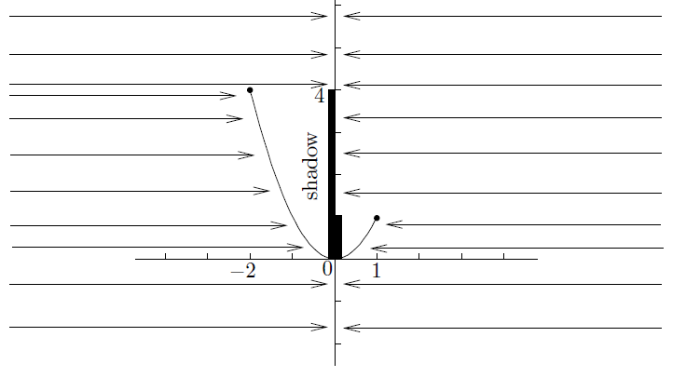

Figure 2. the range is [0, 4]

* Remember, the codomain of any function we look at will always be the set of all real numbers.
* codomain ≠ range.

1. The vertical line test

* How to judge whether it is a function? -> check the vertical lines: whether two or more points on the graph can lie on the same vertical line, see **Figure 3 and 4**.

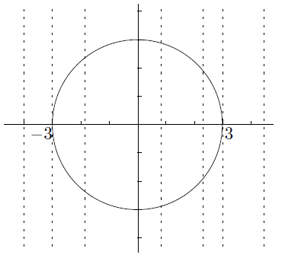

Figure 3. Not a function ($x^{2}+y^{2}=9$)

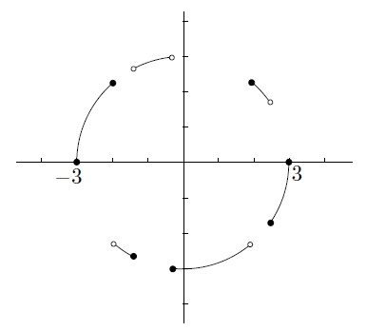

Figure 4. A function

1. Inverse Functions

* Start with a function *f* such that for any *y* in the range of *f*, there is exactly one number *x* such that *f*(*x*) = *y*. That is, different inputs give different outputs. Now we will define the inverse function *f*-1.
* The domain of *f*-1 is the same as the range of *f*.
* The range of *f*-1 is the same as the domain of *f*.
* The value of *f*-1(*y*) is the number *x* such that *f*(*x*) = *y*. So,

if *f*(*x*) = *y*; then *f*-1(*y*) = *x*.

1. The horizontal line test

* How to judge whether the function has an inverse function? -> check the horizontal lines: whether even one horizontal line intersects the graph more than once, see **Figure 5 and 6**.

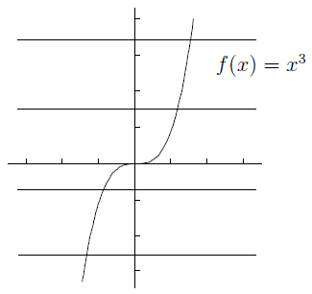

Figure 5. Inverse function existed

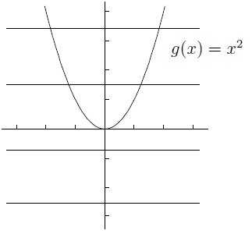

Figure 6. Inverse function doesn't exist

1. Finding the inverse

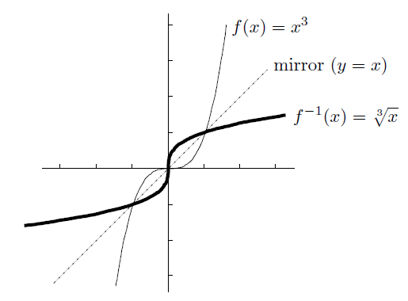

Figure 7. Draw the line y=x to find the inverse

1. Inverses of inverse functions

If the domain of a function *f* can be restricted so that *f* has an inverse *f*-1, then

* *f*(*f*-1(*y*)) = *y* for all *y* in the range of *f*; but
* *f*-1(*f*(*x*)) may not equal *x*; in fact, *f*-1(*f*(*x*)) = *x* only when *x* is in the restricted domain

1. Composition of Functions

* *f*(x) = *h*(*g*(*x*)) can be expressed as *f* = *h* O *g*, so

*f*(x) = *m*(*k*(*j*(*h*(*g*(*x*))))) can write *f* = *m* O *k* O *j* O *h* O *g*

1. Odd and Even Functions

* Even Functions: *f*(-*x*) = *f*(*x*)
* Odd Functions: *f*(-*x*) = -*f*(*x*)
* Remember, odd functions must pass through the origin if they are defined at 0
* The product of two odd functions is always an even function, the product of two even functions is always even, and also that the product of an odd and an even function must be odd

1. Graphs of Linear Functions

* *f*(*x*)=*mx*+*b*, the slope is *m*, and the y-intercept is *b*. See **Figure 8**.

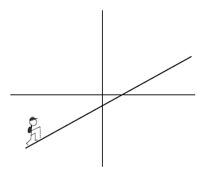

Figure 8. f(x)=mx+b

* the *point-slope* form of a linear function

If a line goes through (*x*0, *y*0) and has slope *m*,

then its equation is $y-y_{0}=m(x-x_{0})$.

1. Common Functions and Graphs

* **Polynomials:** these are functions built out of nonnegative integer powers of *x*. You start with the building blocks 1, *x*, *x2*, *x*3, and so on, and you are allowed to multiply these basic functions by numbers and add a finite number of them together.
* The highest number *n* such that *x*n has a nonzero coefficient is called the *degree* of the polynomial.

$$p\left(x\right)=a_{n}x^{n}+a_{n-1}x^{n-1}+⋯+a_{2}x^{2}+a_{1}x^{1}+a_{0}$$

where *a*n is the coefficient of *xn*, *a*n-1 is the coefficient of *x*n-1, and so on down to *a*0, which is the coefficient of 1.

* **Quadratics: $p\left(x\right)=a_{2}x^{2}+a_{1}x^{1}+a_{0}$** , it has two, one, or zero (real) roots, depending on the sign of the *discriminant $∆$* . $∆=b^{2}+4ac$, There are three possibilities. If $∆>0$, then there are two roots; if $∆=0$, there is one root (called a *double root*); and if $∆<0$, then there are no roots. In the first two cases, the roots are given by
$$\frac{-b±\sqrt{b^{2}-4ac}}{2ac}$$

* An important technique for dealing with quadratics is *completing the square*, like
$$2x^{2}-3x+10=2\left(x^{2}-\frac{3}{2}x+5\right)=2\left(\left(x^{2}-\frac{3}{2}x+\frac{9}{16}\right)+5-\frac{9}{16}\right)=2\left({\left(x-\frac{3}{4}\right)}^{2}+\frac{71}{16}\right)$$

* **Rational functions:** these are functions of the form

$$\frac{p(x)}{q(x)}$$

where *p* and *q* are polynomials. Some simplest examples are **Figure 9**:

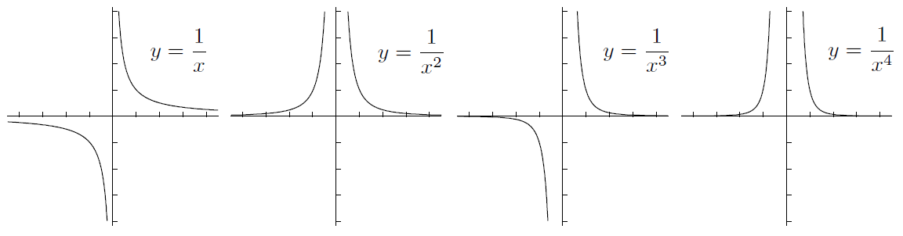

Figure 9. Some simplest rational functions

* **Exponentials and logarithms:** exponentials are $y=b^{x}$, the domain is the whole real line, the *y-intercept* is 1, the range is $(0, ∞)$, and there is a horizontal asymptote on the left or right at *y*=0. Since it satisfies the horizontal line test, there is an inverse function: the base *b* logarithm, which is written $y=\log_{b}{(x)}$. The range is all of $(-∞,∞)$, and there’s a vertical asymptote at *x*=0. See **Figure 10**:

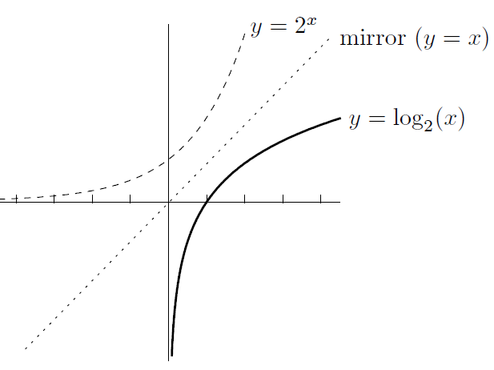

Figure 10. Base b is 2

**CHAPTER 2 Review of Trigonometry**



1. The Basics

* circumference: 圆周, 周长, 胸围; right-angled: 直角的; hypotenuse: 直角三角形的斜边; reciprocal: 互惠的, 相互的, 倒数的, 彼此相反的;
* The circumference of a circle of radius 1 unit is 2π units, see **Figure 11**:

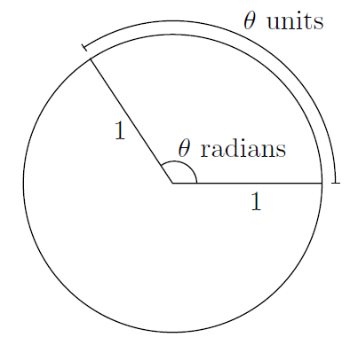

Figure 11. A circle of radius 1 unit

* The transfer formula between radians and degrees:
$$angle in radians=\frac{π}{180}×angle in degrees$$

* A right-angled triangle **Figure 12**:

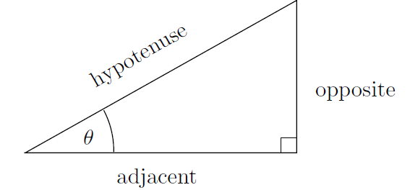

Figure 12. A right-angled triangle

$$\sin\left(θ\right)=\frac{opposite}{hypotenuse}, \cos\left(θ\right)=\frac{adjacent}{hypotenuse}, and \tan\left(θ\right)=\frac{opposite}{adjacent}.$$

We’ll also be using the reciprocal functions csc, sec, and cot:

$$\csc{(x)}=\frac{1}{\sin{(x)}}, \sec{(x)}=\frac{1}{\cos{(x)}}, and \cot{(x)}=\frac{1}{\tan{(x)}}.$$

* A nice table **Figure 13**:

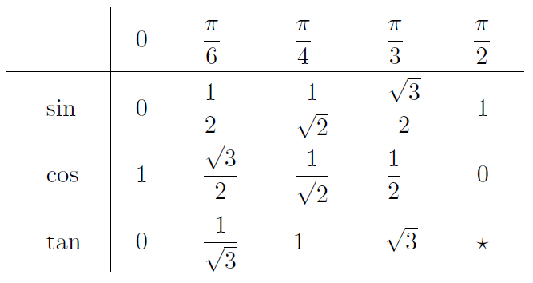

Figure 13. A nice table (the star means that tan(π/2) is undefined)

1. Extending the Domain of Trig Functions
2. The ASTC method

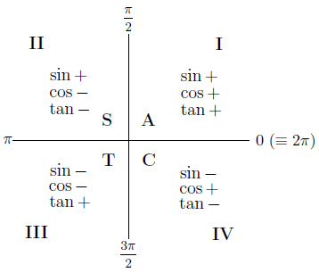

Figure 14. The ASTC method (All Sin Tan Cos)

1. The Graphs of Trig Functions

* $y=\sin{(x)}$ (period 2π, odd), see **Figure 15:**

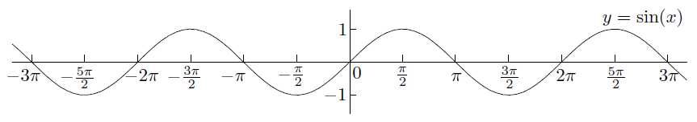

Figure 15. y=sin(x)

* $y=\cos{(x)}$ (period 2π, even), see **Figure 16:**

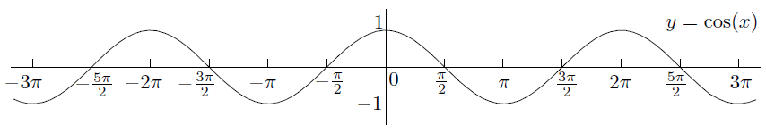

Figure 16. y=cos(x)

* $y=\tan{(x)}$ (period π, odd), see **Figure 17:**

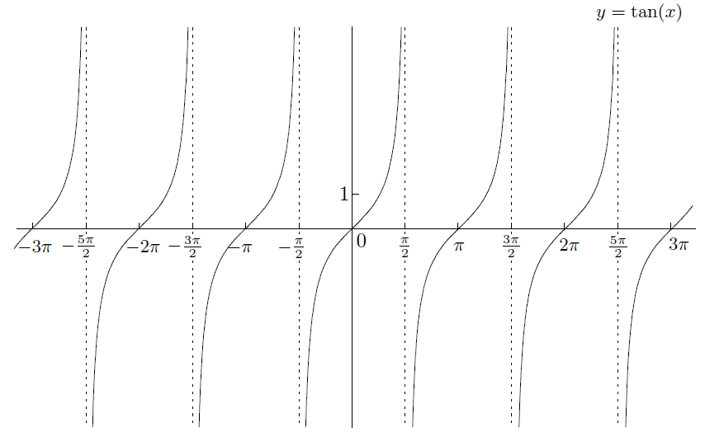

Figure 17. tan(x)

* $y=\sec{(x)}$ (period 2π, even), see **Figure 18:**

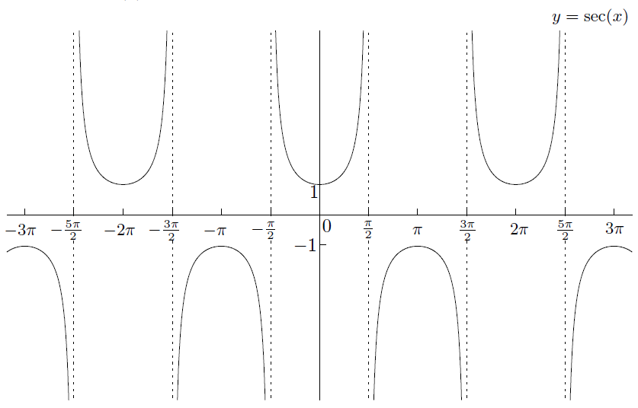

Figure 18. sec(x)

* $y=\csc{(x)}$ (period 2π, odd), see **Figure 19:**

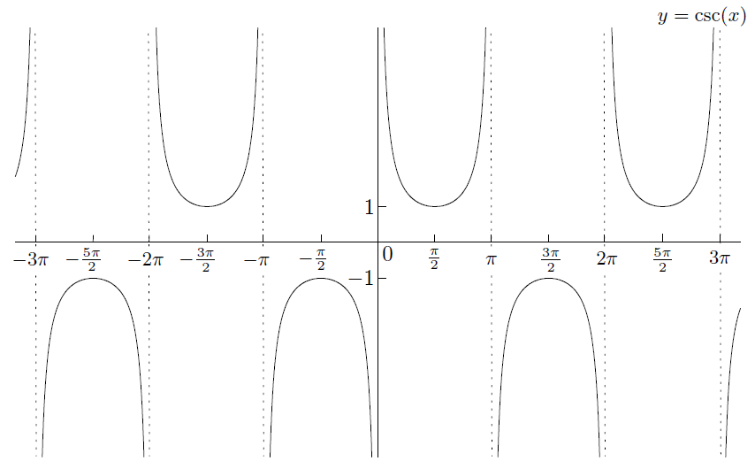

Figure 19. csc(x)

* $y=\cot{(x)}$ (period π, odd), see **Figure 20:**

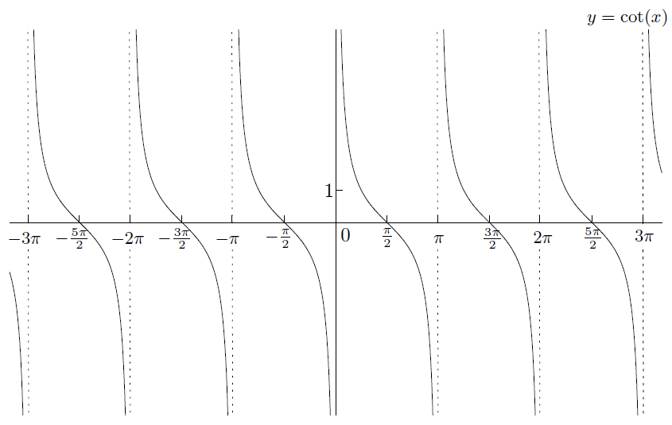

Figure 20. cot(x)

1. Trig Identities

$$\cos^{2}{(x)}+\sin^{2}{(x)}=1$$

$$1+\tan^{2}{(x)}=\sec^{2}{(x)}$$

$$\cot^{2}{(x)}+1=\csc^{2}{(x)}$$

* $trig function\left(x\right)=co-trig function(\frac{π}{2}-x)$**:**

$$\sin\left(x\right)=\cos{(\frac{π}{2}-x)}, \tan\left(x\right)=\cot{(\frac{π}{2}-x)}, and \sec\left(x\right)=\csc{(\frac{π}{2}-x)}.$$

or

$$\cos\left(x\right)=\sin{(\frac{π}{2}-x)}, \cot\left(x\right)=\tan{(\frac{π}{2}-x)}, and \csc\left(x\right)=\sec{(\frac{π}{2}-x)}.$$

Specifically, you should remember that

$$\sin{(A+B)}=\sin{(A)}\cos{(B)}+\cos{(A)}\sin{(B)}$$

$$\cos{(A+B)}=\cos{(A)}\cos{(B)}-\sin{(A)}\sin{(B)}$$

The double-angle formulas are

**CHAPTER 3 Introduction to Limits**



1. Limits: The Basic Idea

* An example:

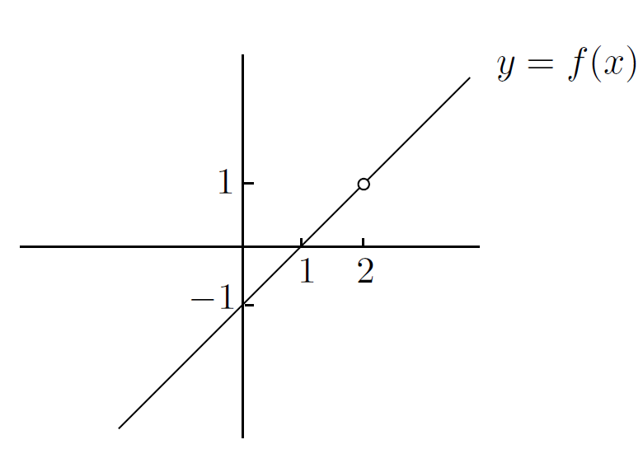

Figure 21.

* Modify it slightly:

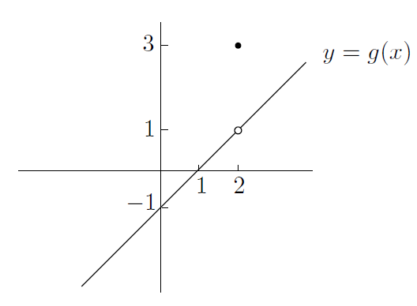

Figure 22.

1. Left-Hand and Right-Hand Limits

* How you would describe the behavior of near :

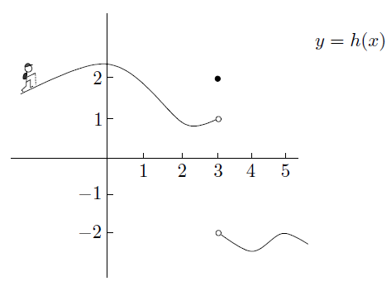

We can summarize

and

* The regular two-sided limit at exists **exactly** **when** both left-hand and right-hand limits at exist **and are equal to each other**!

I’m saying that

and

is the same thing as

If the left-hand and right-hand limits are not equal, then the two-sided limit does not exist. We'd just write

does not exist

1. When the Limit Does Not Exist

* A formal definition of the term “vertical asymptote”:

“ has a vertical asymptote at ” means that at least one of and is equal to or .

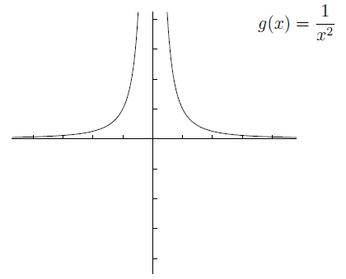

1. Limits at and

* How a function behaves when gets really huge:

“ has a right-hand horizontal asymptote at ” means that .

“ has a left-hand horizontal asymptote at ” means that .

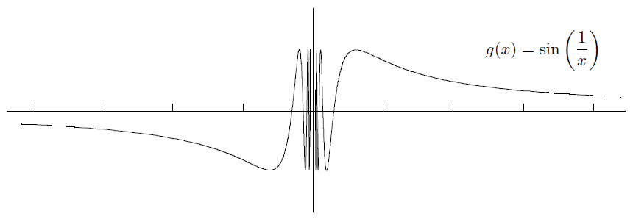

* Large numbers and small numbers

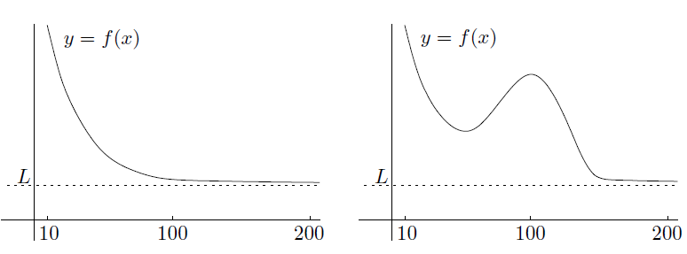

1. Two Common Misconceptions about Asymptotes

* First, a function doesn't have to have the same horizontal asymptote on the left as on the right

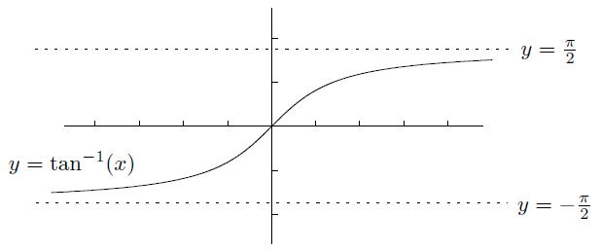

and

* A function can't cross its asymptote

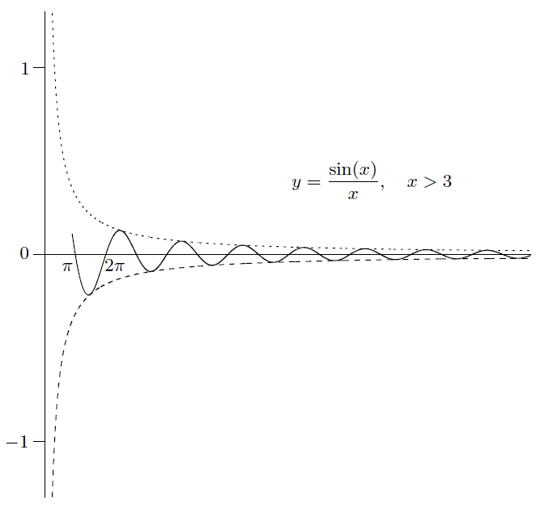

1. The Sandwich Principle

* The *sandwich principle*, also known as the *squeeze principle*, says that if a function is sandwiched between two functions and that converge to the same limit as , then also converges to as .

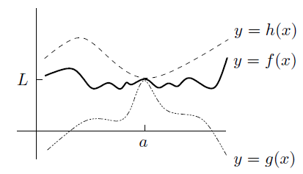

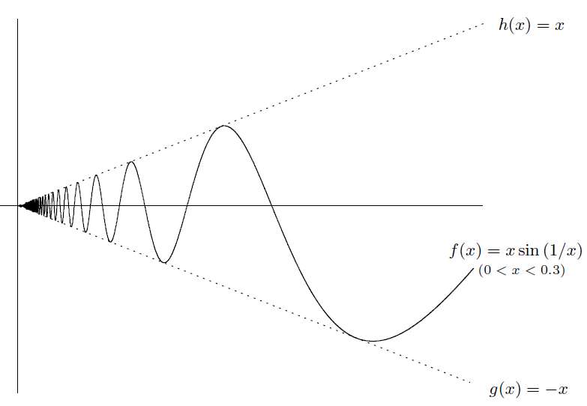

* In summary, here's what the sandwich principle says:

If for all near , and , then

1. Summary of Basic Types of Limits

* The right-hand limit at . Behavior of to the left of , and at itself, is irrelevant

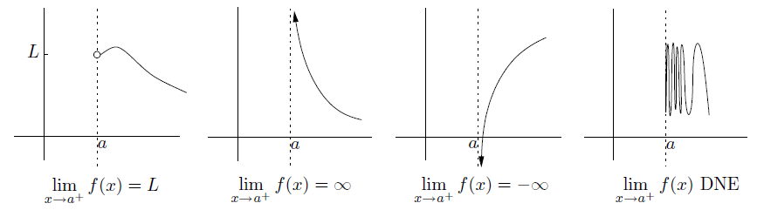

* The left-hand limit at . Behavior of to the right of , and at itself, is irrelevant

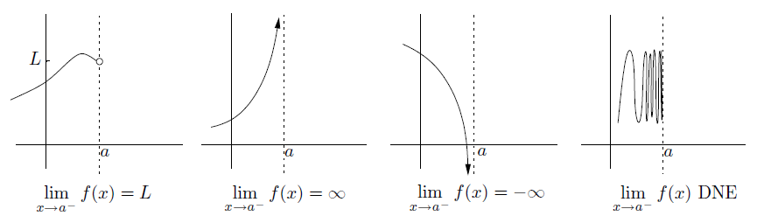

* The two-sided limit at

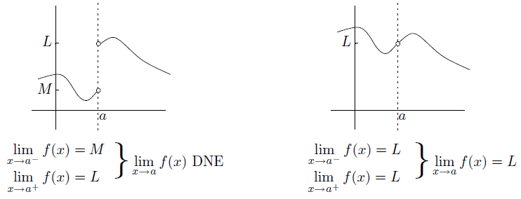

* The limit as

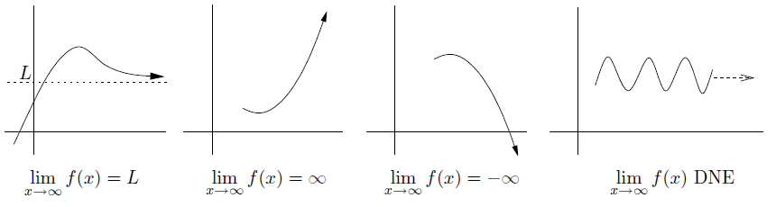

* The limit as

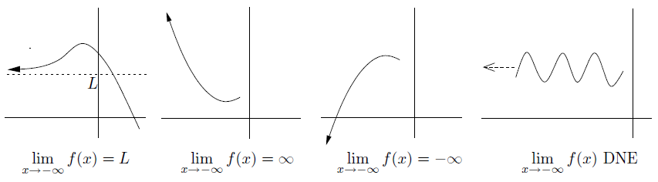

**CHAPTER 4 How to Solve Limit Problems Involving Polynomials**



1. Limits Involving Rational Functions as

* Let's start off with limits that look like this:

,

where and are polynomials and is a finite number. (Remember that the quotient of two polynomials is called a rational function.)

* The first thing you should always try is to substitute the value of for
* The formula for the difference of two cubes:
* Since we are taking limits, we use the plugging-in technique after factoring and canceling

1. Limits Involving Square Roots as

* Consider the following limit:
* conjugate expression:

1. Limits Involving Rational Functions as

* We are now trying to find limits of the form
* Here's a very important property of a polynomial: when is large, the leading term dominates
* More generally, you can use the following theorem:

for any , as long as is constant.

* So we have proved that
* Method and examples

1. Limits Involving Poly-type Functions as

* These aren't polynomials because they involve fractional powers or th roots, for example, let's consider
* Now let's see what happens when we modify the situation very slightly. Consider
* But wait, you say-what if they are the same? For example, what is

Use conjugate expression

1. Limits Involving Rational Functions as

* Now let's spend a little time on limits of the form

where and are polynomials or even poly-type functions. All the principles

we've been using apply equally well here

* There's only one other thing you have to beware

when is negative

for all (positive, negative, or zero)

If and you want to write , the only thing you need a minus sign in front of is when is even and m is odd

1. Limits Involving Absolute Values

* Sometimes you have to deal with functions involving absolute values. Consider this limit:

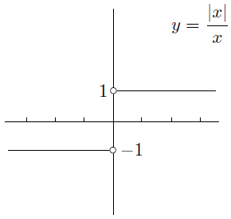

* A very slight variation of the above example is

we see that it matters whether or . These conditions can be rewritten as or

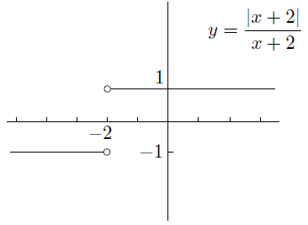

**CHAPTER 5 Continuity and Differentiability**



1. Continuity

* The intuition is that you can draw the graph of the function in one piece, without lifting your pen off the page
* Continuity at a point

A function is *continuous* as if

we can be a little more precise about the definition and explicitly require three things to be true:

1. The two-sided limit exists (and is finite)
2. The function is defined at ; that is, exists (and is finite)
3. The two above quantities are equal: that is,

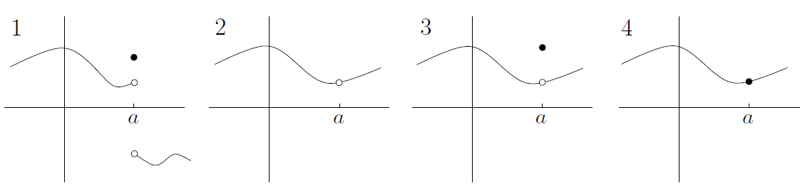

* Continuity on an interval

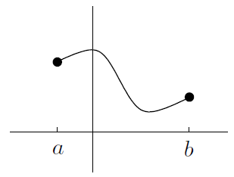

We say that a function is continuous on if

1. the function is continuous at every point in
2. the function is *right-continuous* at . That is, exists (and is finite), exists, and these two quantities are equal; and
3. the function is *left-continuous* at . That is, exists (and is finite), exists, and these two quantities are equal

* Examples of continuous functions. For example, every polynomial is continuous. Also, if you add, subtract, multiply or take the composition of two continuous functions, you get another continuous function. The same is almost true if you divide one continuous function by another: the quotient function is continuous everywhere except where the denominator is 0.

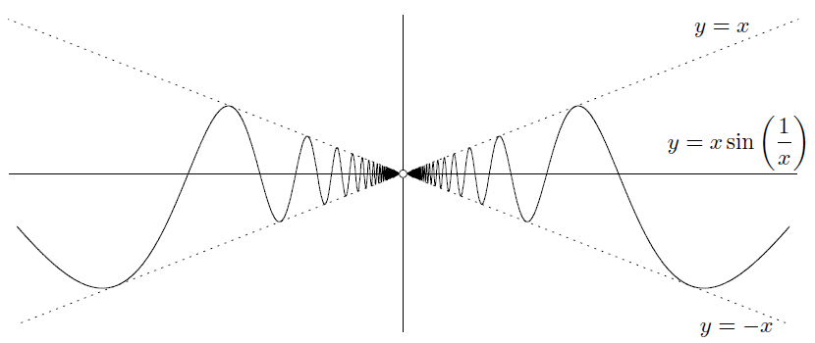

* Knowing that a function is continuous brings some benefits. The first is called the *Intermediate Value Theorem* (IVT)

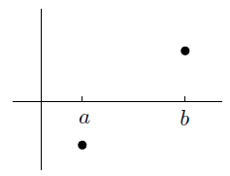

**Intermediate Value Theorem**: if is continuous on , and and , then there is at least one number in the interval such that . The same is true if instead and .

Here's a slightly harder example. How would you show that the equation has a solution? The first step is to use a little trick: **put everything onto the left-hand side**. So, instead of solving , we try to solve .

* A harder IVT example

Any polynomial of odd degree has at least one root

* The second benefit of knowing that a function is continuous: Maxima and minima of continuous functions

**Max-Min Theorem**: if is continuous on , then has at least one maximum and one minimum on .

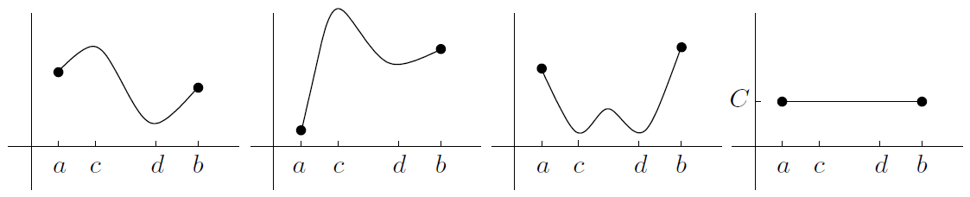

If the function isn’t continuous, the following diagrams show some potential problems:

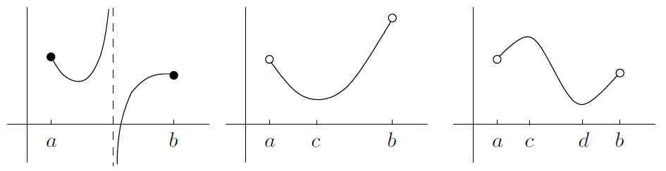

So, you can only use the theorem to guarantee the existence of a maximum and minimum in an interval if you know the function is continuous on the entire closed interval

1. Differentiability

* Differentiability. This essentially means that the function has a derivative. One of the original inspirations for developing calculus came from trying to understand the relationship between speed, distance, and time for moving objects
* Average speed
* Instantaneous velocity

In particular, suppose that at time , the car is at position . That is, let

* The graphical interpretation of velocity

We have a graphical interpretation for average velocity over the time period to

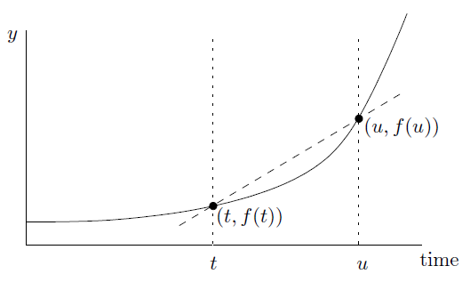

Try to find a similar interpretation for the instantaneous velocity

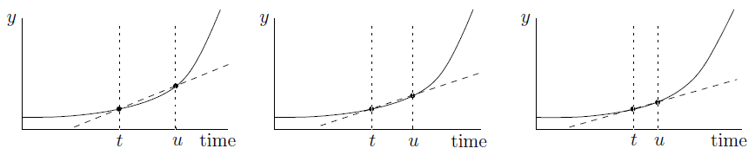

We'd like to say that the instantaneous velocity is exactly equal to the slope of the tangent line through

* Tangent lines

The tangent line doesn't have to intersect the curve only once!

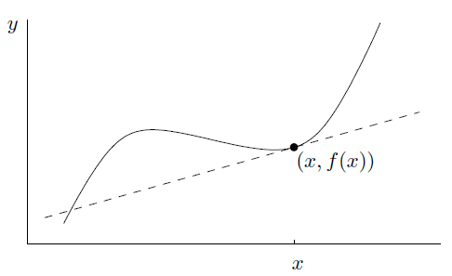

It's possible that there's no tangent line through a given point on a graph

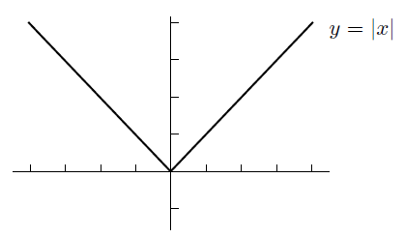

Start by picking a number which is close to

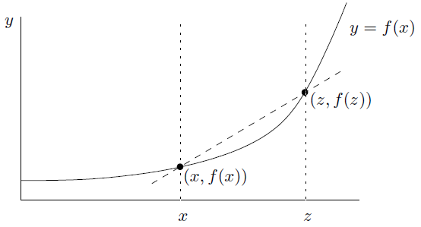

* The derivative function

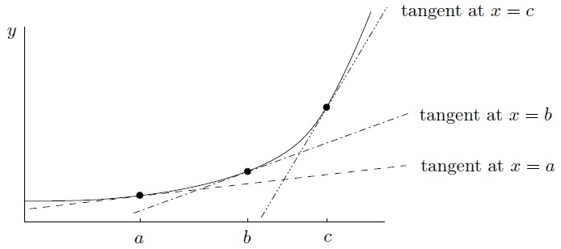

As for the parabola , its derivative is

* The derivative as a limiting ratio

Here the symbol means “change in,” so that is just the change in

Notice that isn’t actually equal to the ratio of to : it's equal to the limit of that ratio as tends to

We'd now like to write , which should mean “really really tiny change in ,” and similarly for

If , then you can write instead of

and are the same thing. Finally, remember that the quantity is not actually a fraction at all-it's the limit of the fraction as

* The derivative of linear functions

In our case, the graph of is just a line of slope and -intercept equal to . Then the tangent at any point on the line is just the line itself! This means that the value of should be no matter what is

As you might expect, only linear functions have constant slope

By the way, if is actually constant, so that , then the slope is always . So we've proved that the derivative of a constant function is identically

* Second and higher-order derivatives

There's a similar sort of notation for the second derivative:

If , then you can write instead of

The third derivative of as being the derivative of the second derivative of

The notation is particularly convenient for higher derivatives. That way, any derivative can be written in the form for some integer .

* When the derivative does not exist

We know the graph of has a sharp corner at the origin

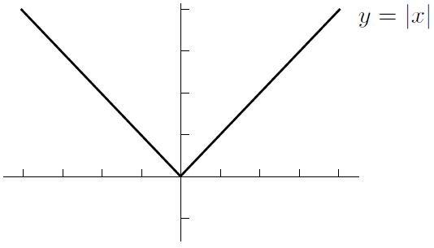

The point is that if , at the right-hand derivative is and the left-hand derivative is . Since the left-hand slope doesn't equal the right-hand slope, there can be no derivative at .

In conclusion, there are continuous functions which are not differentiable, but all differentiable functions are continuous.

* Differentiability and continuity

If a function is differentiable at , then it's continuous at .

Differentiable functions are automatically continuous. Remember, though, that continuous functions aren't always differentiable!

So, how do we prove our big claim? Let's start by seeing what we want to prove. To show that is continuous at , we're going to need to show that

Before we proceed farther, I want to substitute as we've done before. In that case, , and as , we see that . So the above equation can be replaced by

Now that we are aware of our destination, let's start with what we actually know. Well, we know that is differentiable at ; this means that exists, so by the deffnition of , the limit

exists. We know that exists. We still need to do something clever. The trick is to start with another limit:

we can work out this limit exactly by splitting it into two factors:

On the other hand, we could have taken the original limit and instead canceled out the factor of to get

Of course, the value of doesn't depend on the limit at all:

**CHAPTER 6 How to Solve Differentiation Problems**



1. Finding Derivatives Using the Definition

If is constant, then

1. Finding Derivatives (the Nice Way)

* Constant multiples of functions
* Sums and differences of functions

It's even easier to differentiate sums and differences of functions: just differentiate each piece and then add or subtract.

* Products of functions via the product rule

Product rule (version 1): if , then

Product rule (version 2): if , then

Product rule (three variables): if , then

* Quotients of functions via the quotient rule

Quotients rule (version 1): if , then

Quotients rule (version 2): if , then

* Composition of functions via the chain rule

Chain rule (version 1): if , then

Chain rule (version 2): if is a function of , and is a function of , then

* A nasty example
* Justification of the product rule and the chain rule

1. Finding the Equation of a Tangent Line

* One benefit of finding derivatives is that you can use derivatives to find the equation of a tangent line to a given curve

1. **find the slope**
2. **find a point on the line**
3. **use the point-slope form**
4. Velocity and Acceleration

* Another application of finding derivatives is to compute velocities and accelerations of moving objects

velocity

acceleration

* Constant negative acceleration

An object thrown at time from initial height with initial velocity satisfies the equations

, , and

1. Limits Which Are Derivatives in Disguise

* If you get stuck on a limit, it might be a derivative in disguise. Telltale signs are that the dummy variable is by itself in the denominator, and the numerator is the difference of two quantities. Even if this doesn't happen, you could still be dealing with a derivative in disguise

1. Derivatives of Piecewise-Defined Functions
2. Sketching Derivative Graphs Directly

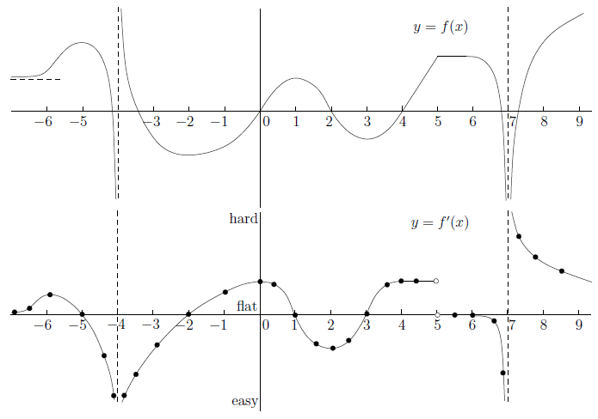

**CHAPTER 7 Trig Limits and Derivatives**



1. Limits Involving Trig Functions

* The small case

It is true in the limit as :

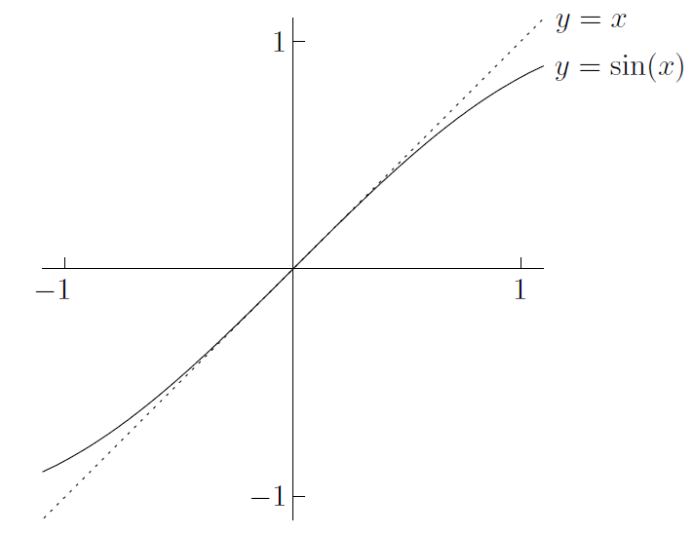

Look at

So we have shown that

What happens to as

* Solving problems-the small case

and

* The large case

and for any

Using the sandwich principle, you can treat or as being

of lower degree than any positive power of , so long as you are only adding or subtracting

More precisely, if you are solving a problem of the form

where and are polynomials or poly-type functions but with some sines and cosines added on, then the degrees of the top and bottom are the same as they would be without the sines and cosines added on. The only exception is when or has degree 0; then the trig part could be significant

In practice, most mathematicians would have established the general principle that

for any positive exponent , and similarly when sine is replaced by cosine

* The “other” case

Consider the limit

A good general principle when dealing with a limit involving for some is to **shift the problem to by substituting**

* Proof of an important limit

Now it's time to prove it

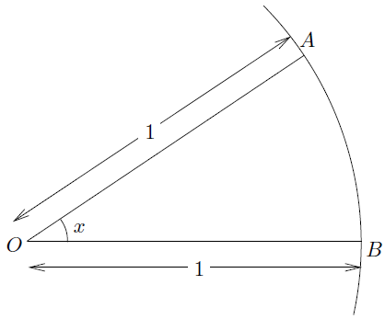

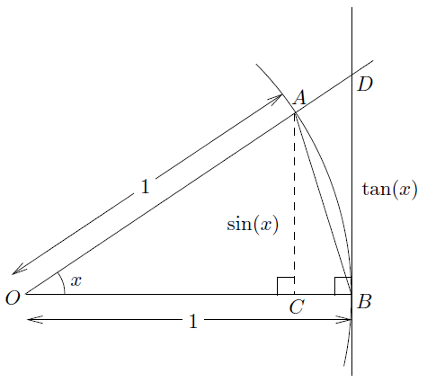

for

Let's first take reciprocals of the nice inequality, and multiply by the positive quantity

By the sandwich principle

To prove that the left-hand limit is set

1. Derivatives Involving Trig Functions

* Examples of differentiating trig functions
* Simple harmonic motion

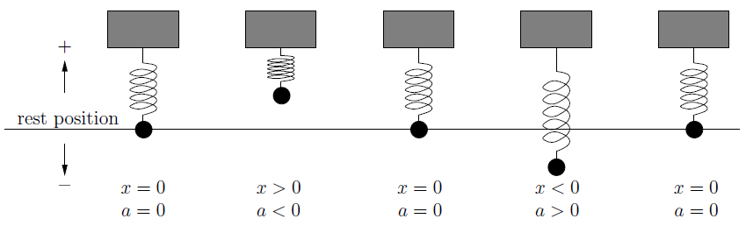

* A curious function

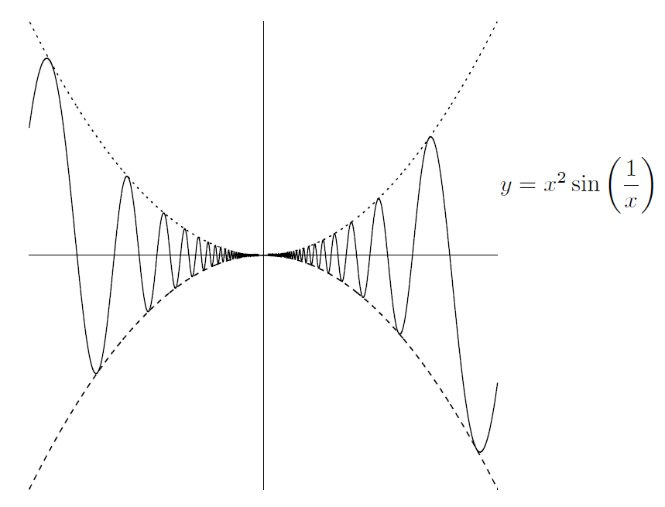

But DNE, neither does

So, there are functions out there which are differentiable, yet their derivatives aren't continuous

**CHAPTER 8 Implicit Differentiation and Related Rates**



1. Implicit Differentiation

Consider the following two derivatives:

and

The best way is to say to yourself that the first of the derivatives above is asking how much the quantity changes when we change a little bit. On the other hand, think of second this way, if you change , then will change a little bit; this change in will cause to change. (All this is true only if depends on , of course-if not, then when you change , nothing at all will happen to

* Techniques and examples

Now it's time to get practical. Consider the following equation:

whack a in front of both sides:

Here's another example: if

Now let's differentiate the above equation:

Finally, plug in and to see that:

But do you see how we might have saved a little effort? Go back to the second equation, we could have saved a little time by plugging and into the above equation, which can easily reduce . So a good rule of thumb is **that if you only need the derivative at a certain point, substitute before rearranging**-it often saves time.

Here's a brief summary of the above methods:

1. in your original equation, differentiate everything and simplify using the chain, product, and quotient rules;
2. if you want to find , rearrange and divide to solve for ; but
3. if instead you want to find the slope or equation of the tangent at a particular point on the curve, first substitute the known values of and , then rearrange to find . Then use the point-slope formula to find the equation of the tangent, if needed

* Finding the second derivative implicitly

It's also possible to differentiate twice to get the second derivative. For example, if

Now, if you want to differentiate twice, you have to start by differentiating once! You should get

Differentiate the above equation with respect to :

Beware: the quantities

and

are completely different!

Finally, we can write this as

Phew. That was exhausting. We're not done yet, though: we still need to find when and . So plug that in to the above equation: you get

We still need ! So put and to second equation above and get

Put that into our second derivative equation and we will get

when and , so we're finally done!

1. Related Rates

Consider two quantities-they can measure anything you like-that are related

to each other. If you know one, you can find the other

Of course, as one of the two quantities changes, so does the other. Suppose that we know how fast one of the quantities is changing. Then how fast is the other one changing? That is exactly what we mean by the term *related rates*. You see, a *rate of change* is the speed at which a quantity is changing over time

Here's the real definition: **the rate of change of a quantity is the derivative of with respect to time**. That is,

if is some quantity, then the rate of change of is

When you see the word \rate," you should automatically think “”

So, let's look at a general overview of how to solve problems involving related rates:

1. Read the question. Identify all the quantities and note which one you need to find the rate of. Draw a picture if you need to!
2. Write down an equation (sometimes you need more than one) that relates all the quantities. To do this, you may need to do some geometry, possibly involving similar triangles. If you have more than one equation, try to solve them simultaneously to eliminate unnecessary variables.
3. Differentiate your remaining equation(s) implicitly with respect to time . That is, whack both sides of each equation with a . You end up with one or more equations relating the rates of change.
4. Finally, substitute values for everything you know into all the equations you have. Solve the equations simultaneously to find the rate you need.

Just one more thing before we look at examples: it's vital that you **substitute values at the** **end, after differentiating**! That is, don't switch steps 3 and 4. If you substitute values first, denying the quantities the ability to change, then your rates will all be 0. That's what you get for freezing everything in place. . . .

* A simple example

Suppose that a perfectly spherical balloon is being inflated by a pump. Air is entering the balloon at the constant rate of cubic inches per second. At what rate does the radius of the balloon change at the instant when the radius itself is inches? Also, at what rate does the radius change when the volume is cubic inches?

OK, let's write down our quantities (step 1):

These are the volume and the radius of the balloon. Let's call the volume (in cubic inches) and the radius (in inches)

Now, we need an equation relating V and r (step 2):

Here's where the geometry comes in. Since the balloon is a sphere, we know that

Now we need to relate the rates (step 3):

Differentiate both sides implicitly with respect to :

Finally, we're ready to substitute (step 4):

In symbols, we have , Plugging this into the above equation, we get

Rearranging leads to

Armed with the formula, we can quickly do both parts of the question. In the first part, we know that the radius is inches, so set in our formula from above:

So the answer is . But what? It's important to write a sentence summarizing the situation, as well as including the **units** of measurement. In this case, we'd say that when the radius is inches, the rate of change of the radius is inches per second

Now, for the second part of the question, we know that the volume is cubic inches. Put and solve for , you should be able to see that inches. Finally, substituting into the equation for gives

So when the volume is cubic inches, the rate of change of the radius is inches per second

* A slightly harder example

Let's look at another relatively straightforward example, this time involving three quantities. Suppose there are two cars, and . Car is driving on a road heading directly north away from your house, and car is driving on a different road heading directly west toward your house. Car travels at miles per hour and car travels at miles per hour. At what rate is the distance between the cars changing when is miles north of your house and car is miles east of your house?

To answer this question, we'd better draw a picture (step 1): Draw your house and the cars and . Let the distance between and be given by ; let the distance between and be called ; and let the distance between the cars be called . The diagram looks like this:

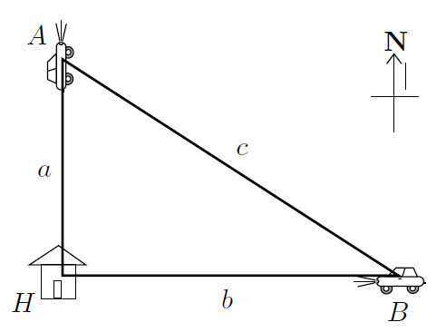

Time for step 2. The equation relating , , and c is nothing other than Pythagoras' Theorem:

Moving on to step 3, we differentiate implicitly with respect to time . Make sure you agree that we get

Now, we know that car is moving at miles an hour away from your house. This means that the distance is increasing by miles per hour, so . As for , it is moving at miles an hour toward your house. This means that is decreasing by miles an hour, so

The end result is that

* A much harder example

Here's a tougher example involving similar triangles: suppose there's a freakin' huge water tank in the shape of a cone (with the point at the bottom). The height of the cone is twice the radius of the cone. Water is being pumped into the tank at the rate of cubic feet per second. At what rate is the water level changing when the volume of water in the tank is cubic feet?

There's a second part as well: assume that the tank develops a little hole at the bottom that causes water to flow out at a rate of one cubic foot per second for every cubic foot of water in the tank. I want to know the same thing as before: at what rate is the water level changing when the volume of water in the tank is cubic feet, but now with the leak in the tank?

Let's start with the first part. Here's a diagram of the situation:

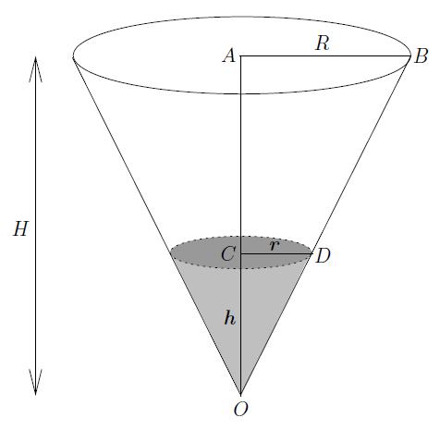

The height of the tank is and its radius is . The height of the water level is and the radius of the top of the water surface is . All these quantities are measured in feet. Let's also let be the volume of water in the tank, measured in cubic feet (step 1)

For step 2, we have to start relating some of these quantities. We are given that the tank's height is twice the radius, so we have . There are some similar triangles in the diagram: in fact, is similar to , so . Since , we have , which means that . The volume of a cone of height units and radius units is given by cubic units. Using the equation , we have

Now, for step 3, let's differentiate this with respect to time . By the chain rule,

Great-now for step 4, substitute in everything we know into the two equations

Above. We know that and we're interested in what happens when . Substituting, we get

and

Final, we get

The second part is almost the same. In fact, the only difference occurs at step 4. We know one cubic foot is leaving per second for every cubic foot of water in the tank. Since there are cubic feet of water in the tank (by definition!), the rate of outflow from the leak is cubic feet per second. So

* A really hard example

Suppose that a plane is flying eastward directly away from you at a height of feet above your head. The plane moves at a constant speed of feet per second. Meanwhile, some time ago a parachutist jumped out of a helicopter (which has since own away). The parachutist is floating directly downward, feet due east of you, at a constant speed of feet per second. The situation is summarized in the following picture:

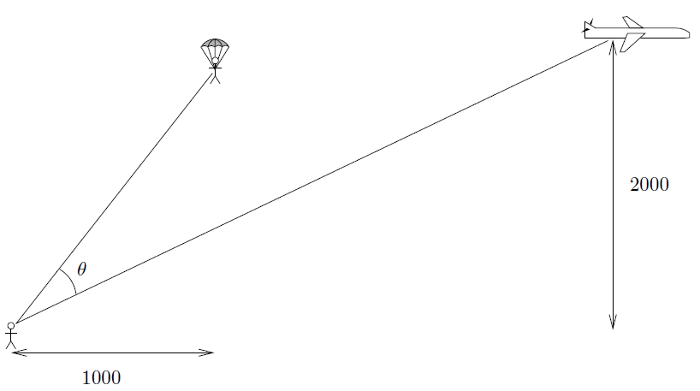

In the picture, what you might call the inter-azimuthal angle between the parachutist and the plane (with respect to you) is marked as . The question is, at what rate is changing when the plane and the parachutist have the same height but the plane is feet due east of you?

Let the plane be feet to the east of you. Let the height be feet. By drawing a few extra lines, we can recast the above diagram as follows:

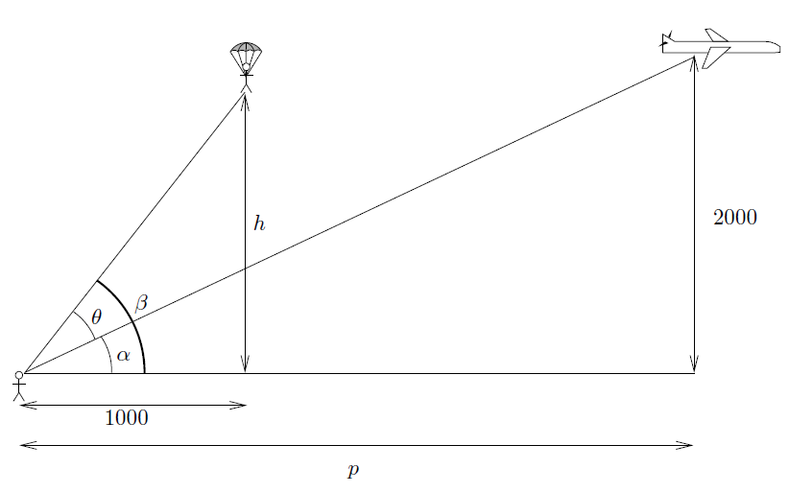

So we know that . Actually, we should probably write , just in case the parachutist is much lower than the plane. At around the time we're interested in, the heights are the same but the plane is much farther to the east than the parachutist, so must be bigger than and we don't need the absolute values

Now, let's do some trig. We have two right-angled triangles

and

Step 2 is finally done, and we can move on to step 3, differentiating these two relations implicitly with respect to time

Now we'd better make some substitutions and get to the bottom of this mess. Well, the speed of the plane is 500 feet per second, which means that . The speed of the parachutist is 10 feet per second, but the height is decreasing, so . We're interested in what happens when the plane is feet away, so , and when the parachutist is at height feet (the same as the plane), so set

Use our trig identities, we get

So

The same with

So for the final equation

So the angle is increasing at a rate of radians per second (at the moment we're considering), and we're finally done

**CHAPTER 9 Exponentials and Logarithms**



1. The Basics

* Review of exponentials

The rough idea is that we'll take a positive number, called the *base*, and raise it to a power called the *exponent*:

For example, the number is an exponential with base and exponent . It's essential that you know the so-called exponential rules, For any base and real numbers and :

1. The zeroth power of any nonzero number is
2. The first power of a number is just the number itself
3. When you multiply two exponentials with the same base, you **add** the exponents.
4. When you divide two exponentials with the same base, you **subtract** the bottom exponent from the top one.
5. When you take the exponential of the exponential, you **multiply** the exponents.

* Review of logarithms

Suppose that you want to solve the following equation for :

The way you can bring down from the exponent is to hit both sides with a logarithm. Since the base on the left-hand side is , the base of the logarithm is . Indeed, by definition, the solution of the above equation is

Let's go back to the equation . We know that this means that . If we now plug that value of into the original equation, we get the bizarre looking formula

In more generality, **is the power you have to raise the base to in order to get** . This means that is the solution of the equation for given and . Plugging this value of in, we get the formula

which is true for any and (except ). Remember is always positive! **You can only take the logarithm of a positive number**

You might also have noticed that I mentioned that is bad. For any base between and : for all , and is greater than .

* Logarithms, exponentials, and inverses

Fix a base and set . The function has domain and range . Since it satisfies the horizontal line test, it has an inverse, which we'll call . The domain of is the range of , which is , while the range of is the domain of , which is . Remembering that the graph of the inverse function is the reflection of the original function

in the mirror line :

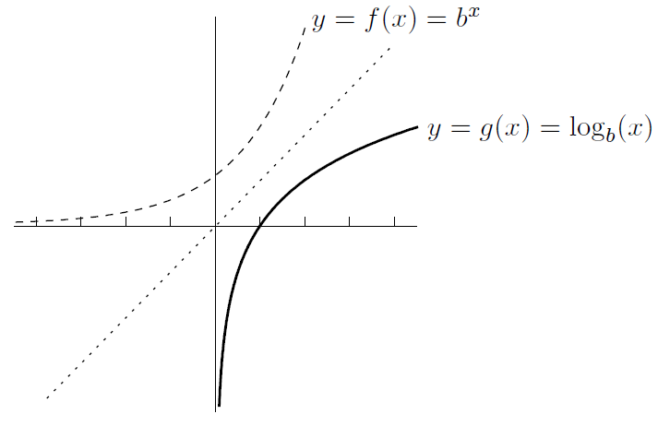

**The exponential of the logarithm is the original number**- provided that the bases match!

**The logarithm of the exponential is the original number** (provided that the bases match!)

* Log rules

Here are the rules, which are valid for any base and positive real numbers and :

1. **The log of the product is the sum of the logs**.
2. **The log of the quotient is the difference of the logs**.
3. **The log moves the exponent down in front of the log**. In this equation, can be any real number (positive, negative or zero).
4. **Change of base rule**:

for any bases and and any number . This means that all the log functions with different bases are really constant multiples of each other. Indeed, the above equation says that

where is constant (it happens to be equal to ), which means it doesn't depend on . We can conclude that the graphs of and are very similar-you just stretch the second one vertically by a factor of to get the first one

Actually, there is a change of base rule for exponentials too: for , , and .

1. Definition of

So far, we haven't done any calculus involving exponentials or logs. Let's start doing some. We'll begin with limits and then move on to derivatives. Along the way, we need to introduce a new constant , which is a special number in the same sort of way that is a special number. One way of seeing where comes from involves a bit of a finance lesson

* A question about compound interest
* The answer to our question

First, let's suppose that we are compounding times a year at an annual rate of . This means that each time we compound, the amount of compounding is . After this happens times in one year, our original fortune has grown by a factor of

We want to know what happens if we compound more and more often; in fact, let's allow to get larger and larger. It would also be nice to know what happens at interest rates other than . So let's replace by and worry about the more general limit

fortune after years, compounded times a year at a rate of per year

With , we have

This means that if you compound more and more frequently at an annual rate of , your fortune will increase by an amount very close to , but never more than that. The quantity is the “fortune-increase limit” we've been looking for. The only way you get this rate of increase is if you compound continuously-that is, all the time!

fortune after years, compounded **continuously** at a rate of per year

The quantities and look quite different, but for large they're almost the same

* More about and logs

Let's take a closer look at our number . Remembering that

we can replace by to get

Of course, corresponds to an interest rate of per year. Let's draw up a little table of values of **to three decimal places** for some different values of :

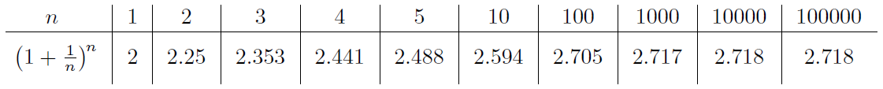

Our number , which is the limit as of the numbers in the second row of the above table, turns out to be an irrational number whose decimal expansion begins like this:

In practice, just knowing that is a little over will be more than enough

We can even write a different way: instead of . The expression “” is **not** pronounced “lin ” or anything like that-just say “” or perhaps “ell en ”, or if you're feeling particularly geeky, “the natural logarithm of ”. In fact, most mathematicians write without a base to mean the same thing as or . The base logarithm is called the *natural logarithm*

Let's take another look at the log rules and formulas we've seen so far, for and :

(Actually, in the second formula, can even be negative or , and in the last formula, can be negative or .)

One more point before we move on to differentiating logs and exponentials. Suppose you take the important limit

and this time substitute . What we’ve found:

and

When , we get two formulas for :

and

These are important!

1. Differentiation of Logs and Exponentials

One of the reasons why the logarithm base is called the natural logarithm is that the derivative of is just

Writing as , we get the important formula

Since , we have proved the nice formula

* Examples of differentiating exponentials and logs

As long as you know the basic formulas for differentiating exponentials and logs (they are the boxed equations in the previous section), then you'll be all set

1. How to Solve Limit Problems Involving Exponentials or Logs

* Limits involving the definition of

To find or construct our classic limit

* Behavior of exponentials near

In fact, since , we know that

This sort of approach works well if your exponential term appears in a product or a quotient, but it fails miserably with something like this:

when the dummy variable is by itself on the bottom, your limit might be a derivative in disguise:

we get the useful fact by replacing by that

* Behavior of logarithms near 1

Now let's look at how logs behave near 1. It turns out that the situation is pretty similar to the case of exponentials near 0. We know that but what is

This is another example of a limit which is a derivative in disguise:

Since , this simplifies to

* Behavior of exponentials near or

Now we want to understand what happens to when or . Let's take another look at the graph of :

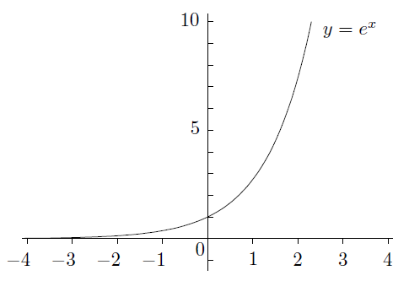

These are special cases of the following important limit:

This is not the whole story. The limit

gets larger and larger, and is larger than

In fact

It is also true if you replace by any power of . Even can’t compete with

So in general we have the following principle:

**Exponentials grow quickly**: no matter how large is

In fact, by tweaking this a little, you can get a more general statement:

For example,

In fact, the base can be replaced by any other base greater than . For example,

* Behavior of logs near

Let's look at what happens to when is a large positive number. (Remember, you can't take the log of any negative number, so there's no point in studying the behavior of logs near ) Here's the graph of once again:

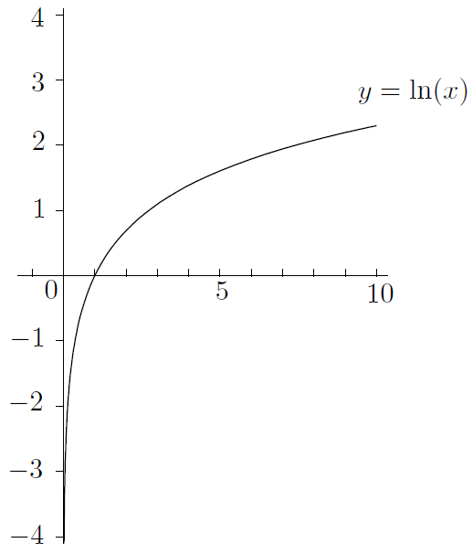

Again, it's important to note that the curve never touches the *y*-axis, even though it looks as if it does. In any event, it seems as if

Actually, goes to infinity much more slowly than any positive power of , even something like . In symbols, we have

**Logs grow slowly**: no matter how small is

Just as in the case of exponentials, it's not too hard to extend this to a more general form:

Actually, we shouldn't be surprised that logs grow slowly, once we know that exponentials grow quickly. After all, logs and exponentials are inverses of each other

* Behavior of logs near 0

The graph of above suggests that

You need to use the right-hand limit here, since isn't even defined for

Consider the limit

Here's one way to solve the above problem. Replace by

**Logs “grow" slowly at 0**: no matter how small is

1. Logarithmic Differentiation

Logarithmic differentiation is a useful technique for dealing with derivatives of things like , where both the base and the exponent are functions of . After all, how on earth would you find

with what we have seen already? It doesn't fit any of the rules. Still, we have these nice log rules which cut exponents down to size. If we let , then

by log rule. Now let's differentiate both sides (implicitly) with respect to :

Set , by the chain rule and product rule,

Now we can get this:

That's the answer we're looking for. (By the way, there is another way we could have done this problem. Instead of using the variable , we could just have used our formula to write

This is also work. When you've finished, you should replace by and check that you get the same answer as the original one above

Let's review the main technique. Suppose you want to find the derivative with respect to of

where both the base and the exponent involve the variable . Here's what you do:

1. Let be the function of you want to differentiate. Take (natural) logs of both sides. The exponent comes down on the right-hand side, so you should get
2. Differentiate both sides implicitly with respect to . The right-hand side often requires the product rule and the chain rule (at least). The left-hand side always works out to be . So you get
3. Multiply both sides by to isolate , then replace by the original expression , and you're done

Even if the base and exponent are not both functions of , logarithmic differentiation can still come in handy. If your function is really nasty and involves lots of products and quotients of powers (like ) and exponentials (like ), you might want to try logarithmic differentiation. For example,

By logarithmic differentiation, that's how. Just take natural logs of both sides, and you'll find that the right-hand side becomes much more manageable

* The derivative of

Now we can finally show something that we've been taking for granted:

for **any** number , not just integers as we've seen before, when

When , we have a bit of a problem. In fact, without using complex numbers, you can only make sense of for when is a rational number with an odd denominator. For

example, makes sense for negative since you can always take a cube root-we're **OK** because is odd. It's not really any different from what we've done before-just that we can handle non-integer exponents now

1. Exponential Growth and Decay

We've seen that bank accounts with continuous compounding grow exponentially. It occurs in nature too. For example, under certain circumstances, populations of animals, like rabbits (and humans!), grow exponentially. There's also exponential decay, where a quantity gets smaller and smaller in an exponential fashion. This occurs in radioactive decay, allowing scientists to find out how old some ancient artifacts, fossils, or rocks are.

Here's the basic idea. Suppose . Then, . The right-hand side of this equation can be written as , since . That is,

This is an example of a *differential equation*. There are other functions satisfying the above equation. For example, if , then , which is once again equal to . More generally, if , then , which is once again equal to . It turns out that this is the **only** way you can have :

If we change the variable to , so that we are looking at This means that the rate of change of is equal to . Interesting! The rate that the quantity is changing depends on how much of the quantity you have. If you have more of the quantity, then it grows faster (assuming ). This makes sense in the case of population growth: the more rabbits you have, the more they can breed. If you have twice as many rabbits, they also **produce** twice as many rabbits in any given time period. The number , which is called the *growth constant*, controls how fast the rabbits are breeding in the first place. The hornier they are, the higher is!

* Exponential growth

So, suppose we have a population which grows exponentially. In symbols, let (or , if you prefer) be the population at time , and let be the growth constant. The differential equation for is

We’ll write to indicate that it represents the population at time . Altogether, we have found the

Remember, is the initial population and is the growth constant

Approximation symbol:

* Exponential decay

Let's turn things upside-down and look at exponential decay. To set the scene, let me tell you that there are certain atoms which are radioactive. They are like little time bombs: after awhile they break apart into different atoms, emitting energy at the same time. The only problem is that you never know when they are going to break apart (we'll say “decay" instead of “break apart"). All you know is that over a given time, there's a certain chance that the decay will happen

For example, you might have a certain type of atom which has a 50% chance of decaying within any 7-year period. So if you have one of these atoms in a box, close the box, and then open it up in 7 years, there's a 50-50 chance that it will have decayed. Of course, it's pretty difficult to see an individual atom! So let's suppose, a little more realistically, that you have a trillion atoms. (That's still a tiny speck of material, by the way.) You put them in the box and come back 7 years later. What do you expect to find? Well, about half the atoms should have decayed, while the other half remain intact. So you should have about half a trillion of the original atoms. What if you come back in another 7 years? Then half the remaining original atoms will be left, leaving you with a quarter of a trillion of the original atoms. Every 7 years, you lose half of your remaining sample

So let's try to write down an equation to model the situation. If is the number (population?) of atoms at time , then I claim that

for some constant . This says that the rate of change of is a negative multiple of

where is the original number of atoms (at time ). is called the *decay constant*

In the above example, we know that it takes years for any sample of atoms to halve in size. This length of time is called the *half-life* of the atom (or material)

Now let's generalize a little. Suppose you have some other radioactive material with a half-life of years:

1. Hyperbolic Functions

Let's change course and look at the so-called *hyperbolic functions*. These are actually exponential functions in disguise, but they are similar to trig functions in many ways. We won't be using them much but they do come up occasionally, so it's good to be familiar with them

We'll start by defining the hyperbolic cosine and hyperbolic sine functions:

These functions behave somewhat like their ordinary cousins, but not exactly. For example,

and

So we have

For any . Not quite the same as the regular old trig identity-the minus makes all the difference. (Indeed, is the equation of a hyperbola.)

How about calculus properties? In any case, we have

and

Now let's look at the graphs of these functions. First, you should try to convince yourself that is an even function of and that is an odd function of . (Just plug in and see what happens.) Furthermore, and (check this too)

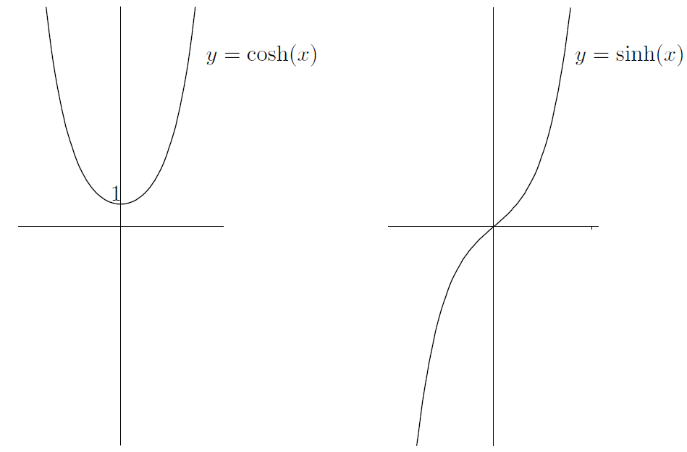

Of course you can define as , as well as the reciprocals

There are also identities connecting the functions, the most important of which is

Now I'm just going to list the derivatives of the other hyperbolic functions and display their graphs

Now the graphs:

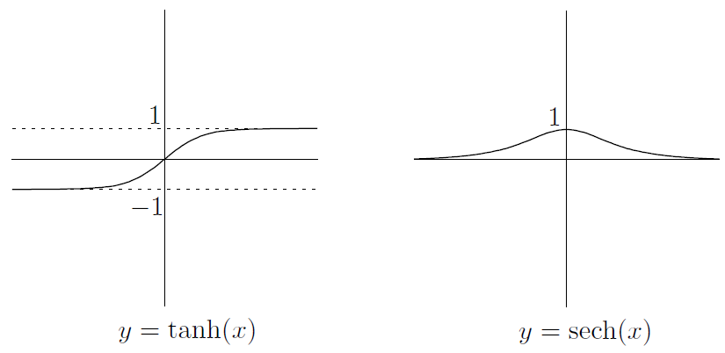

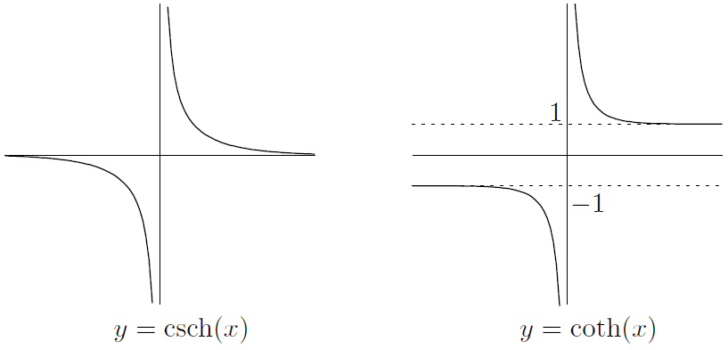

From the definitions of the functions, you can see that all the hyperbolic trig functions are odd functions except for cosh and sech, which are even. This is the same as in the case of regular old trig functions! Also, and both have horizontal asymptotes at and , whereas and have a horizontal asymptote at

**CHAPTER 10 Inverse Functions and Inverse Trig Functions**



1. The Derivative and Inverse Functions

we're going to explore two connections between derivatives and inverse functions

* Using the derivative to show that an inverse exists

Suppose that you have a differentiable function whose derivative is always positive. What do you think the graph of this function looks like? Well, the slope of the tangent has to be positive everywhere, so the function can't dip up and down: it has to go upward as we look from left to right. In other words, the function must be **increasing**

In any case, if our function is always increasing, then it must satisfy the horizontal line test. No horizontal line could possibly hit the graph of twice. Since the horizontal line test is satisfied by , we know that has an inverse. This has given us a nice strategy for showing that a function has an inverse: show that its derivative is always positive on its domain

We've seen that if for all in the domain, then has an inverse. There are some variations. For example, if for all , then the graph is decreasing. The horizontal line test still works, though-the graph is just going down and down, so it can't come back up and hit the same horizontal line twice. Another variation is that the derivative might be for an instant but positive everywhere else. This is **OK** as long as the derivative doesn't stay at for a long time. Here's a summary of the situation:

**Derivatives and inverse functions**: if is differentiable on its domain and any of the following are true:

or

then has an inverse. If instead the domain is of the form , and is continuous on the whole domain, then still has an inverse if any of the above four conditions are true

* Derivatives and inverse functions: what can go wrong

We noticed that the derivative of our function is allowed to be occasionally and the function can still have an inverse. Why can't a little more often? For example, suppose that is defined by

Unfortunately the horizontal line test fails, and there is no inverse! Check out the graph

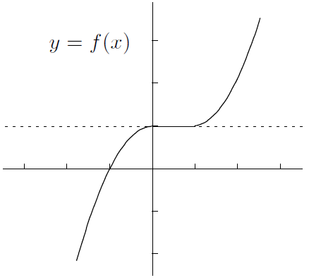

Here's another potential problem. The four conditions on the previous page all require that the domain be an interval like . What if the domain isn't in one piece? Unfortunately, then the conclusion can totally fail to hold. For example, if , then , which can't be negative; however, you can see from the graph that fails the horizontal line

test pretty miserably. So the methods of the previous section won't work, in general, when your function has discontinuities or vertical asymptotes

* Finding the derivative of an inverse function

If you know that a function has an inverse, which we'll call as usual, then what's the derivative of that inverse? Here's how you find it. Start off with the equation . You can rewrite this as . Now differentiate implicitly with respect to to get

The right-hand side is easy: it's just . To find the left-hand side, we use implicit differentiation. If we set , then by the chain rule, we have

Now divide both sides by to get the following principle:

If you want to express everything in terms of , then you have to replace by to get

In words, this means that the derivative of the inverse is basically the reciprocal of the derivative of the original function

Even though the original function is differentiable everywhere, the inverse isn't differentiable everywhere: If you have any function which has an inverse, and it has slope at the point , the inverse function will have infinite slope at the point , as the following picture illustrates:

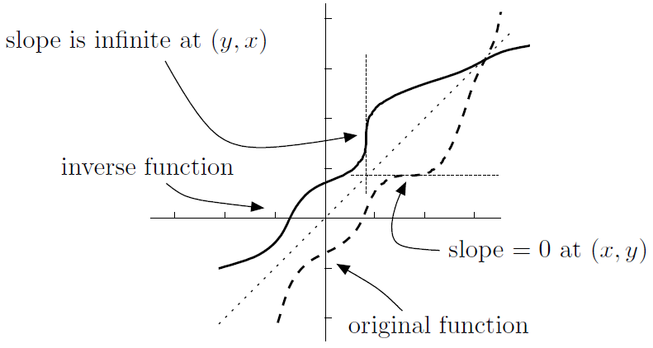

* A big example

1. Inverse Trig Functions

* Inverse sine

Let's start by looking at the graph of once again:

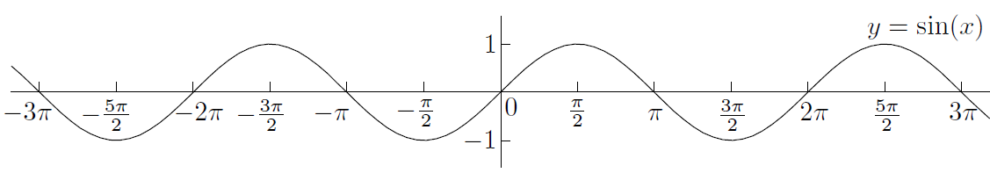

In fact, every horizontal line of height between and intersects the graph **infinitely** many times, which is a lot more than the zero or one time we can tolerate. So, we throw away as little of the domain as possible in order to pass the horizontal line test. There are many options, but the sensible one is to restrict the domain to the interval . Here's the effect of this:

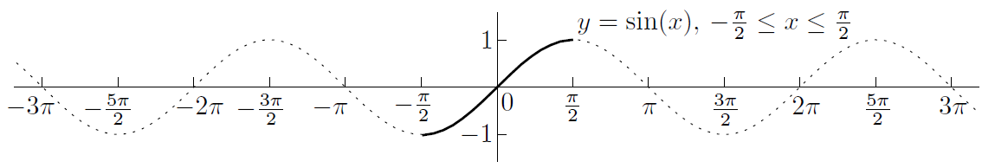

OK, if with domain , then it satisfies the horizontal line test, so it has an inverse . We’ll write as or . (Beware: the first of these notations is a little confusing at first, since does **not** mean the same thing as , even though and . )

So, what is the domain of the inverse sine function? Well, since the range of is , the domain of the inverse function is . And since the domain of our function is , the range of the inverse is

How about the graph of ?

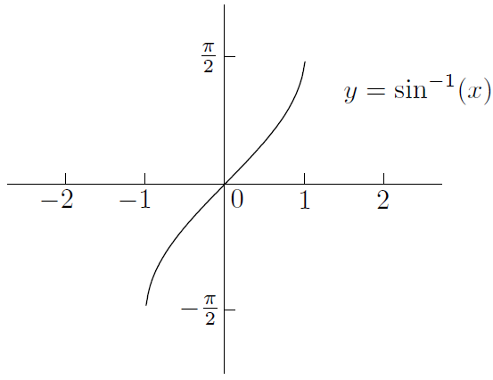

Note that since is an odd function of , so is

Now let's differentiate the inverse sine function

Now, we really want the derivative in terms of , not . No problem-we know that , it shouldn't be too hard to find . In fact, , which means that . This leads to the equation , so we have

But which is it? Plus or minus? If you look at the graph of above, you can see that the slope is always positive:

Note that is not differentiable, even in the one-sided sense, at the endpoints and , since the denominator is in both these cases

Here's a summary of the important facts about the inverse sine function:

* Inverse cosine

Start with the graph of :

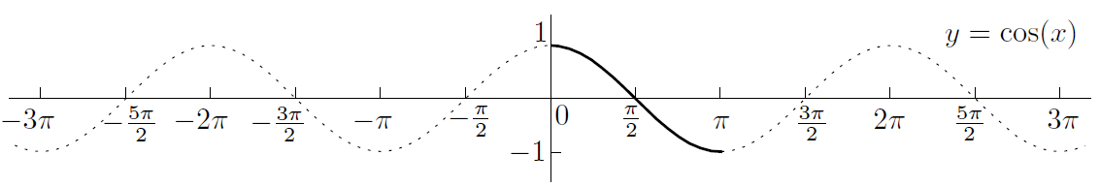

This time, restricting the domain to won't work, since the horizontal line test would fail and also we'd be throwing away part of the range that would be useful. You can see that the section between is highlighted and obeys the horizontal line test. We get an inverse function which we write as or arccos. Like inverse sine, the domain of inverse cosine is , since that's the range of cosine. On the other hand, the range of inverse cosine is , since that's the restricted domain of cosine that we're using. The graph of :

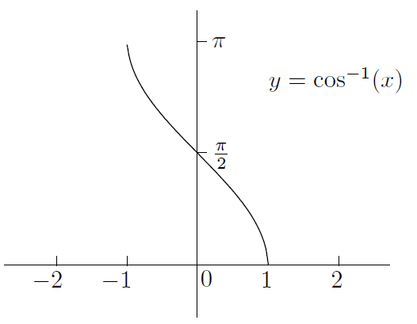

Notice that the graph shows that is neither even nor odd

Unlike the case of inverse sine, the graph of inverse cosine is all downhill, which means that the slope is always negative, so we get

Here are the other facts about inverse cosine that we collected above:

Let's just look at the derivatives of inverse sine and inverse cosine side by side:

The derivatives are negatives of each other! Let's try to see why this makes sense

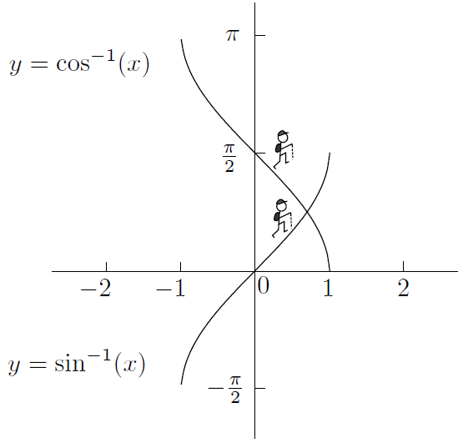

Indeed, we now know that

So has constant slope , which means that it's at as a pancake. We've just used calculus to prove the following identity:

for any in the interval . Look at the following diagram:

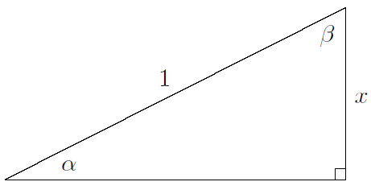

Since , we have . Similarly, which means that . But , which means that

once again. Kind of nice how the calculus agrees with the geometry, huh?

* Inverse tangent

Let's remember the graph of :

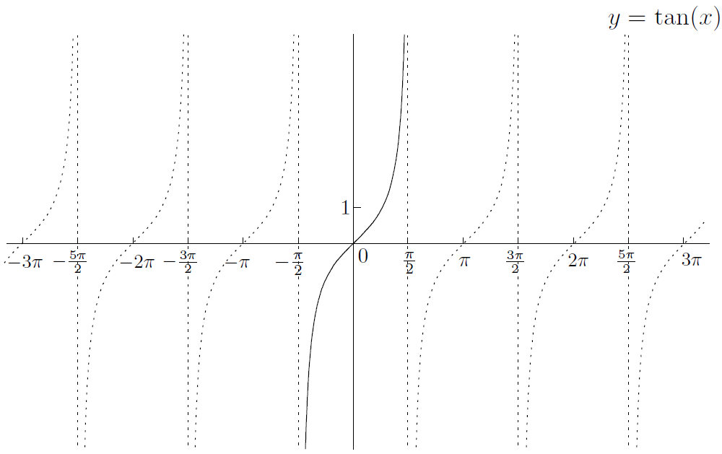

We'll restrict the domain to so that we can get an inverse function , also written as arctan. The domain of this function is the range of the tangent function, which is all of . The range of the inverse function is . The graph of looks like this:

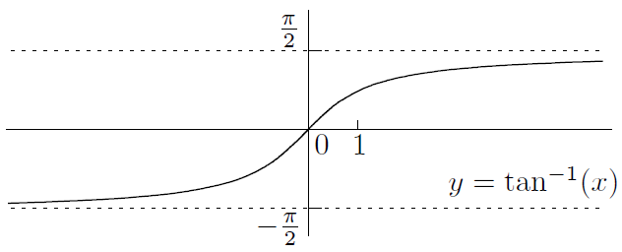

Now is an odd function of , as you can see from the graph-it inherits its oddness from that of

Now let's differentiate with respect to . Write and differentiate implicitly with respect to . Since , and , we see that . This means that

We also have the following facts from above:

is odd; it has domainand range

Unlike inverse sine and inverse cosine, the inverse tangent function has horizontal asymptotes. This means that we have the following useful limits:

and

* Inverse secant

Here's the graph of :

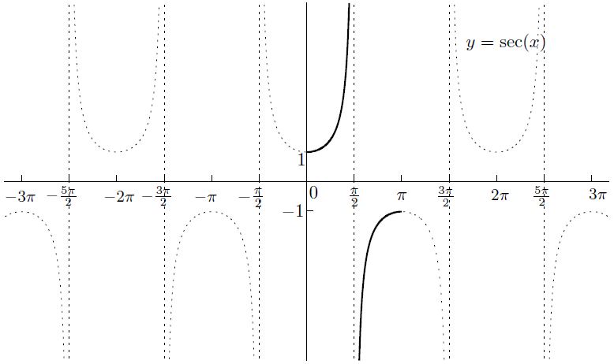

The situation is (unsurprisingly) very similar to the one we faced when we inverted the cosine function. The domain has to be restricted to , except for the point , which isn't even in the original domain of . The range of secant is the union of the two intervals and , so this becomes the domain of the inverse function (alternatively arcsec). As for the range of , it's the same as the restricted domain: minus the point . The graph looks like this:

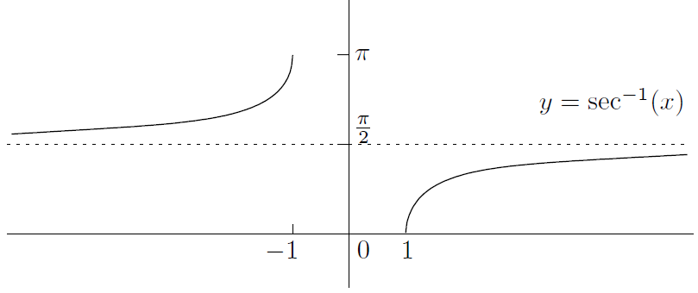

Note that there's a two-sided horizontal asymptote at , so

and

Let's find the derivative. If then . So since , we can rearrange and take square roots to show that . This means that

Is it plus or minus? Looking at the graph above, in fact we need to be a little more clever-instead of the plus or minus, we can simply put instead of and we always get something positive. That is,

We can summarize the other facts about inverse secant like this:

is neither odd nor even; it has domain and range

* Inverse cosecant and inverse cotangent

You can repeat the above analyses to find the domain, range, and graphs of and :

is odd; it has domainand range

is neither odd nor even; it has domain and range

This is what the graphs look like:

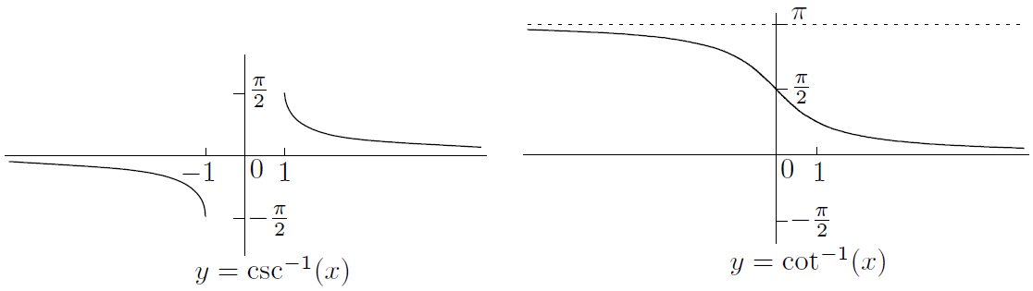

Both functions have horizontal asymptotes:

and

and

Notice that the graphs of and from above are very similar; in fact, you can get one from the other by flipping about the line . This is exactly the same relation as the one that and have with each other:

* Computing inverse trig functions

We've completed a pretty thorough survey of the inverse trig functions. Since you have a few more derivative rules, it's a great idea to practice differentiating functions involving inverse trig functions. For one thing, you should try to make sure that you can compute quantities like without stretching your brain:

Now, here's some more interesting questions:

Just remember that tan is positive in the third quadrant!

Luckily, it's not: the answer is just . In general, , provided that is in the domain of inverse sine. The trouble comes when you try to write . This just isn't true

The trick in both cases is to use the trig identity

In fact, we've noticed that must always be nonnegative, even if is negative. This is because is in the interval , and sine is nonnegative on that interval

1. Inverse Hyperbolic Functions

The situation is a little different for hyperbolic functions. If you want an inverse for , you have to throw away the left half of the graph, just as you do when you take the positive square root (and throw away the negative one). On the other hand, already satisfies the horizontal line test. So we get two inverse functions with the following properties:

is neither odd nor even; it has domain and range

is odd; its domain and range are all of

The graphs are obtained by reflecting the original graphs in the line as usual:

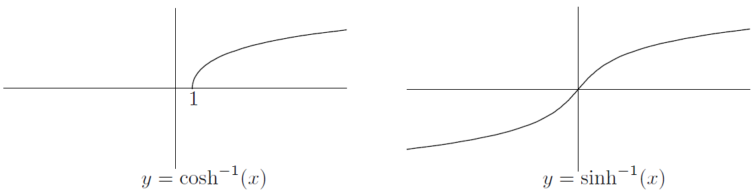

The derivatives are obtained in the same way that we got the derivatives of the inverse trig functions

Now, let's forget about the calculus for a few seconds and recall the definitions of and :

Since we can write and in terms of exponentials, we should be able to write the inverse functions in terms of logarithms. After all, exponentials and logarithms are inverses of each other

when

for all

* The rest of the inverse hyperbolic functions

So far, we've only looked at hyperbolic sine and cosine. If you repeat the analysis for the other four hyperbolic functions, you should be able to conclude that:

is odd; its domain is ; its range is all of

is neither even nor odd; its domain is ; its range is

is odd; its domain and range are both

is odd; its domain is ; its range is

Note that we've restricted the domain of sech to in order to get an inverse, just as we did for cosh

Now, here are the graphs:

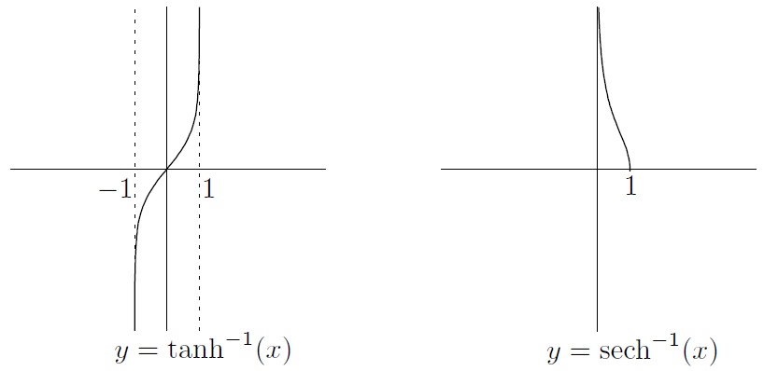

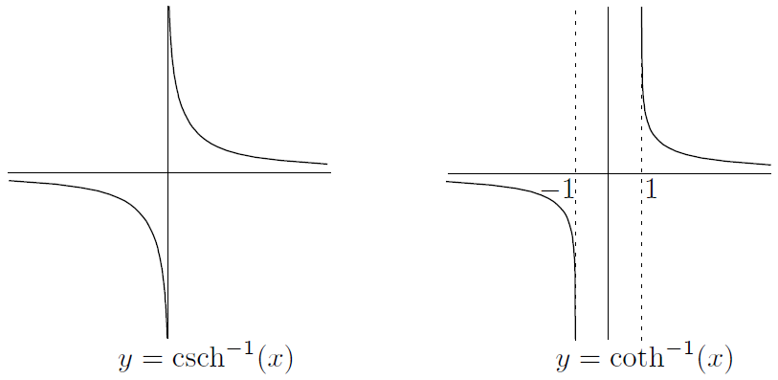

Finally, you can find the derivatives using the standard trick of solving for and differentiating implicitly with respect to . Here's what the derivatives turn out to be:

**CHAPTER 11 The Derivative and Graphs**



1. Extrema of Functions

If we say that is an *extremum* of a function , this means that has a maximum or minimum at . (The plural of “extremum” is “extrema,” of course.) In any event, we need to go a little deeper and distinguish between two types of extrema: global and local

* Global and local extrema

The basic idea of a maximum is that it occurs when the function value is highest. Think about where the maximum of the following function on its domain should be:

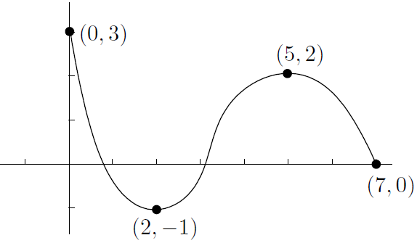

Let's say that a *global maximum* (or *absolute maximum*) occurs at if is the highest value of on the **entire** domain of . In symbols, we want for any value in the domain of . We're simply being more precise and saying “global maxima” instead of just “maxima.”

As we noted before, there could be multiple global maxima; for example, has a maximum value of , but this occurs for infinitely many values of . (These values are all the integer multiples of , as you can see from the graph of .)

How about that other type of maximum? Let's say that a *local maximum* (or *relative maximum*) occurs at if is the highest value of **on some small interval containing**

In fact, it's pretty obvious that **every global maximum is also a local maximum**

In the same way, we can define global and local minima

* The Extreme Value Theorem

In Chapter 5, we looked at the Max-Min Theorem. This says that a **continuous** function on a **closed** interval must have a global maximum somewhere in the interval and also a global minimum somewhere in the interval

The problem with the Max-Min Theorem is that it doesn't tell you anything about where these global maxima and minima are. That's where the derivative comes in. Let's say that is a *critical point* for the function if either or if does not exist. Then we have this nice result:

**Extreme Value Theorem**: suppose that is defined on and is in . If is a local maximum or minimum of , then must be a critical point for . That is, either or does not exist

So local maxima and minima in an open interval occur only at critical points. But it's not true that a critical point must be a local maximum or minimum! For example,

The above theorem applies to open intervals. How about when the domain of your function is a closed interval ? Then the endpoints and might be local maxima and minima; they aren't covered by the theorem. So in the case of a closed interval, local maxima and minima can occur only at critical points or at the endpoints of the interval

* How to find global maxima and minima

The Extreme Value Theorem really makes finding global extrema pretty easy, since it narrows down where they can be. Here's the idea: every global extremum is also a local extremum. Local extrema can only occur at critical points. So just find all the critical points and look at the corresponding function values. The biggest one gives the global maximum, while the smallest gives the global minimum! In gory detail, here's how to find the global maximum and minimum of the function with domain :

1. Find . Make a list of all the points in where does not exist or . That is, make a list of all the critical points in the interval
2. Add the endpoints and to the list
3. For each of the points in the list, find the -coordinates by substituting into the equation
4. Pick the highest -coordinate and note all the values of from the list corresponding to that -coordinate. These are the global maxima
5. Do the same for the lowest -coordinate to find the global minima

Notice: since isn’t even a number, can’t be an extremum

1. Rolle's Theorem

Imagine you're driving down a long straight highway. I watch you stop at a gas station. Then you proceed, always facing the same direction, although you can put the car in reverse if you want. Later on, I see you at the gas station again, without watching what you did in the meantime. I make the following conclusion: at some point when I wasn't looking, your car had velocity equal to zero

This is the content of Rolle's Theorem, which says:

**Rolle’s Theorem**: suppose that is continuous on and differentiable on . If , then there must be at least one number in such that

Now, let's look at some pictures of a few possibilities of functions where Rolle's Theorem applies:

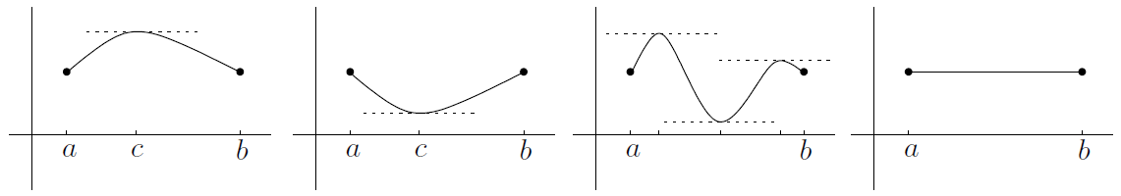

Now, let's look at some pictures where Rolle's Theorem does **not** apply:

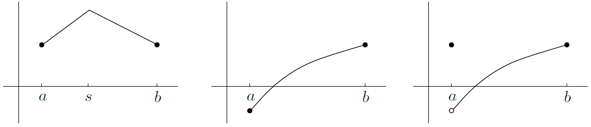

1. The Mean Value Theorem

Suppose you go on another journey, and I find out that you have traveled miles in hours. Your average velocity was miles per hour. This doesn't mean that you were going at exactly miles per hour the whole time. Now, here's my question: were you ever going at miles per hour, even for an instant? The answer is yes. Even if you go at mph for the first hour and mph for the second hour, you still have to accelerate from the slow velocity to the fast velocity. This leads to the Mean Value Theorem, which says:

**The Mean Value Theorem**: suppose that is continuous on and differentiable on . Then there’s at least one number in such that

Let's look at a picture of the situation. Suppose your function looks like this:

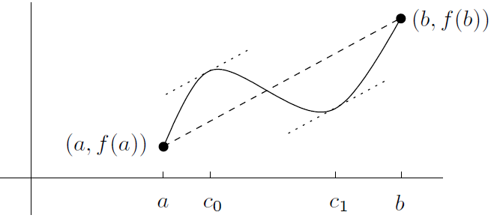

The Mean Value Theorem looks a lot like Rolle's Theorem. In fact, the conditions for applying the two theorems are almost the same. In fact, if you apply the Mean Value Theorem to a function satisfying , you'll see that , so you get a number in satisfying . So the Mean Value Theorem reduces to Rolle's Theorem!

* Consequences of the Mean Value Theorem

We've been taking a few things about the derivative for granted. For example, if a function has derivative equal to everywhere, it must be constant. Facts like this seem obvious but they actually deserve to be proved. Let's use the Mean Value Theorem to show three useful facts about derivatives:

1. Suppose that a function has derivative for **every** x in some interval :

if for all in , then is constant on

1. Suppose that two differentiable functions have exactly the same derivative. Are they the same function? Not necessarily. They could differ by a constant

if for all , then for some constant

This fact will be very useful when we look at integration in a few chapters' time

1. If a function has a derivative that's always positive, then it must be *increasing*. This means that if , then . On the other hand, if for all , the function is always *decreasing*; this means that if then
2. The Second Derivative and Graphs

So far, we haven't paid much attention to the second derivative. We've only used it to define acceleration, and that's about all. Actually, the second derivative can tell you a lot about what

the graph of your function looks like

We'll say a function is *concave up* on an interval if its slope is always increasing on that interval, or equivalently if its second derivative is always positive on the interval (assuming that the second derivative exists):

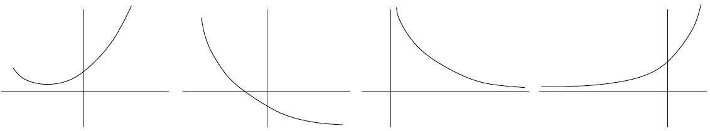

They all look like part of a bowl. Notice that you can't tell anything about the sign of the first derivative just by knowing that

If instead the second derivative is negative, then everything is reversed. Saying that is *concave down* on any interval where its second derivative is always negative:

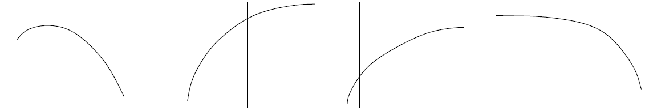

Of course, the concavity doesn't have to be the same everywhere: it can change:

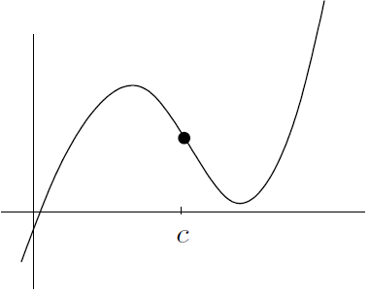

We'll say that the point is a point of inflection for because the concavity changes as you go from left to right through

* More about points of inflection

In the above picture, we see that to the left of and to the right of . What about itself? It must be 0, since everything is nice and smooth

Assuming of course that actually exists when is near , it must be true that

if , is a point of inflection for , then

On the other hand, if , then may or may not be an inflection point! That is,

if , then it's not always true that is a point of inflection for

1. Classifying Points Where the Derivative Vanishes

It's time to apply some of the above theory to a practical problem. Suppose that you have a function and a number such that . You can say for sure that is a critical point for , but what else can you say? It turns out that there are only three common possibilities: could be a local maximum; it could be a local minimum; or it could be a horizontal point of inflection, which means that it is a point of inflection with a horizontal tangent line (Another possibility is that the concavity isn't even well-defined near the critical point. For example, ):

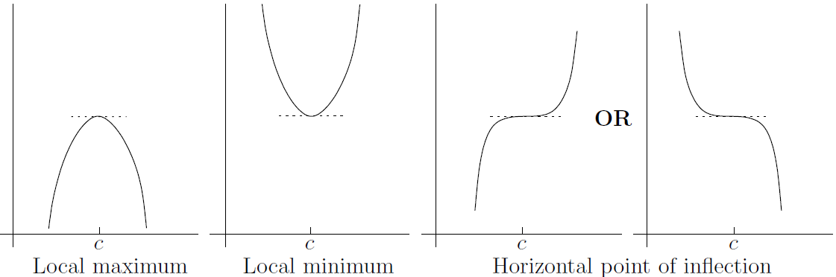

* Using the first derivative

Here's a summary of what we have just observed. Suppose that . Then:

* if changes sign from positive to negative as you pass from left to right through , then is a local maximum;
* if changes sign from negative to positive as you pass from left to right through , then is a local minimum;
* if doesn't change sign as you pass through from left to right, then is a horizontal point of inflection

If we now set , then :

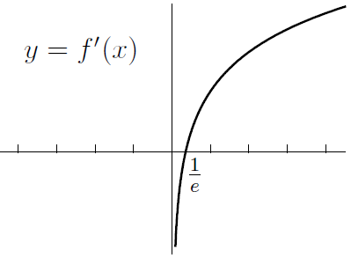

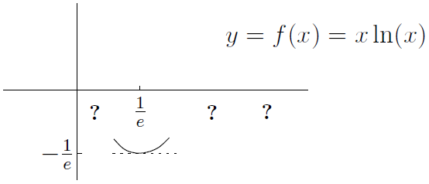

* Using the second derivative

Take another look at the common possibilities which arise when :



Here's the summary of the situation. Suppose that . Then:

* if , then is a local maximum;
* if , then is a local minimum;
* if , then you can't tell what happens! Use the first derivative test from the previous section

Yes, the first derivative test is better, although it's a little more cumbersome to use. It always works, while the second derivative test sometimes lets you down

**CHAPTER 12 Sketching Graphs**



Now it's time to look at a general method for sketching the graph of for some given function . When we sketch a graph, we're not looking for perfection; we just want to illustrate the main features of the graph. Indeed, we're going to use the calculus tools we've developed: limits to understand the asymptotes, the first derivative to understand maxima and minima, and

the second derivative to investigate the concavity

1. How to Construct a Table of Signs

Suppose you want to sketch the graph of . For any number , the quantity could be positive, negative, zero, or undefined. Luckily, if is continuous except for maybe a few points, and you can find all of the zeroes and discontinuities of , then it's easy to see where is positive and where it's negative by using a table of signs

Here's how it works: start off by making a list of all the zeroes and discontinuities of in ascending order. For example, if

The table would look like this (with three rows and plenty of columns):

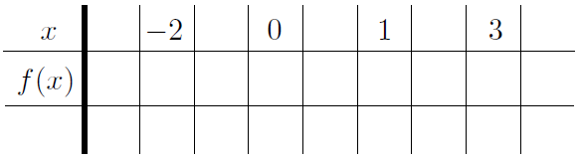

Now you can fill in some of the second row-just put a where is and a star where is discontinuous

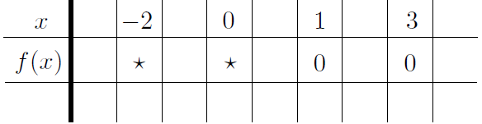

Next, pick your favorite number between each of the special numbers on the top, as well as one at the beginning and one at the end

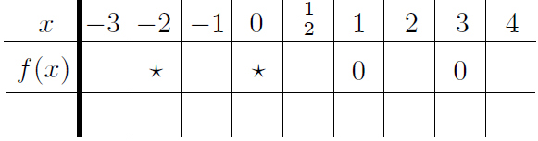

Now, the next thing is to find whether is positive or negative for each of the values we just chose. Since we could care less about the value of : we only care whether it's positive or negative

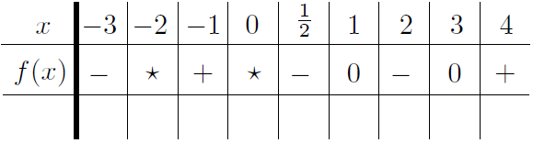

The main point is not that is negative, but that is negative for **all** . The number is just a representative sample point for the region

For now, let's see how to make a table of signs for the derivative and the second derivative

* Making a table of signs for the derivative

A table of signs for the derivative can summarize all this information in a compact, simple way:

whenever the derivative is positive, the function is increasing; when the derivative is negative, the function is decreasing; and when the derivative is , the function has a local maximum, a local minimum, or a horizontal point of inflection

The method is the same as for the table of signs for that we looked at above, except that now you apply it to instead. The only other difference is that when is zero, we'll put a little at line in the third row; when is positive, the line will slope upward; and when is negative, the line will slope downward. Let's see how it works for our previous example where . We calculated that

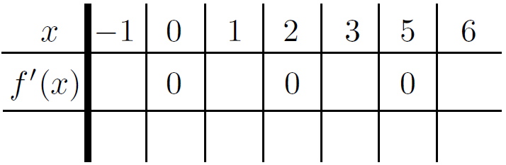

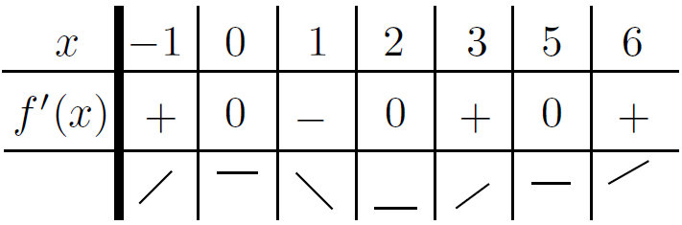

A word of warning: the lines in the third row of the table are meant only to guide you as you sketch the graph of . The graph probably doesn't look like a collection of lines tacked together! Instead, just use the information in that third row to understand where the graph is increasing, decreasing or temporarily flat

* Making a table of signs for the second derivative

The table of signs for the second derivative tells all: when the sign is positive, the curve is concave up; when the sign is negative, the curve is concave down; and when it's , you may or may not get a point of inflection

The method is the same as for the function or the derivative, except that the third row is now used to show whether the function is concave up or concave down. Put a little upward parabola-like curve whenever the sign is , a downward version when the sign is , and a dot when the sign is . If we return to our example from above, we find that we have

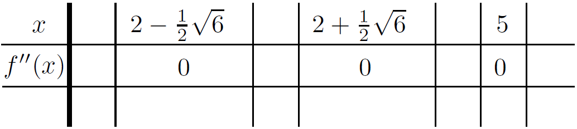

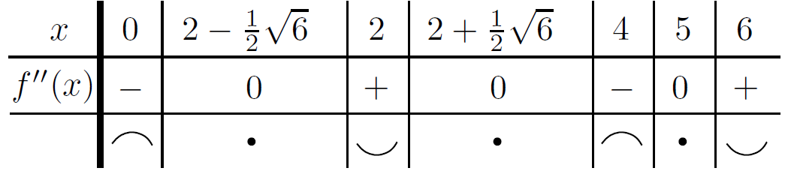

As we noted in the case of the first derivative in the previous section, the pictures in the third row are meant only as a guide to sketching the graph. They show where the original function is concave up and concave down, but they won't necessarily give anything more than a rough idea of what the curve actually looks like. That's why we're going to look at a big method for sketching curves

1. The Big Method

Here is an eleven-step method for sketching the graph of

1. **Symmetry**: check whether the function is even, odd, or neither by replacing by and seeing whether you get back the original function or its negative (you may only need to sketch it for )
2. **-intercept**: find the -intercept (if it exists) by setting
3. **-intercepts**: find the -intercepts by setting and solving for . This is sometimes difficult or impossible!
4. **Domain**: find the domain of . If it's specified in the definition of , there's nothing to do; otherwise, the domain is assumed to be as much of the real line as possible. Remember, you have to avoid numbers which lead to in the denominator, or the square root of a negative number, or the log of a negative number or . If inverse trig functions are involved, the situation is more complicated
5. **Vertical asymptotes**: these generally occur where the denominator is zero (if there is a denominator!). Beware: if the numerator is zero too, then you might have a removable discontinuity instead of a vertical asymptote. Also, you may have a vertical asymptote due to a log factor
6. **Sign of the function**: at this point, draw up a table of signs for . We already know where is zero from above, and we know where it's discontinuous from and . The table tells you exactly where the curve is above or below the -axis
7. **Horizontal asymptotes**: find the horizontal asymptotes by calculating

In any case, draw dashed horizontal lines on your graph to remind you about the horizontal asymptotes, if there are any

1. **Sign of the derivative**: Find the derivative, then find all the critical points-remember, these are points where the derivative is or does not exist. Use the third row of the table to tell where the function is increasing, decreasing, or flat
2. **Maxima and minima**: from the table of signs, you can find all the local maxima or minima-remember, these only occur at critical points. For each maximum or minimum , you also need to find the value of
3. **Sign of the second derivative**: find the second derivative, then find all the points where the second derivative is zero or does not exist. The pictures in the third row of the table indicate where the curve is concave up and where it's concave down
4. **Points of inflection**: use the table of signs for the second derivative to identify the inflection points. Remember, the second derivative at an inflection point has to be zero, and the sign of the second derivative has to be different on either side of the inflection point. For each inflection point , you need to find the -coordinate
5. Examples (Page 252)

Since the original function is odd, its derivative is even and its second derivative is odd

**CHAPTER 13 Optimization and Linearization**



We're now going to look at two practical applications of calculus: optimization and linearization. Basically, optimization involves finding the best situation possible, whether that be the cheapest way to build a bridge without it falling down or something as mundane as finding the fastest driving route to a specific destination. On the other hand, linearization is a useful technique for finding approximate values of hard-to-calculate quantities. It can also be used to find approximate values of zeroes of functions; this is called Newton's method

1. Optimization

To “optimize” something means to make it as good as possible. This being math, we're going for quantity over quality here. The term “optimize” just means “maximize or minimize, as appropriate.”

* An easy optimization example (Page 267)
* Optimization problems: the general method

Here's a way to tackle optimization problems in general:

1. Identify all the variables you might possibly need. One of them should be the quantity you want to maximize or minimize-make sure you know which one! Let's call it for now, although of course it might be another letter like , , or
2. Get a feel for the extremes of the situation, seeing how far you can push your variables
3. Write down equations relating the variables. One of them should be an equation for
4. Try to make a function of only one variable, using all your equations to eliminate the other variables
5. Differentiate with respect to that variable, then find the critical points; remember, these occur where the derivative is or the derivative doesn't exist
6. Find the values of at all the critical points and at the endpoints. Pick out the maximum and minimum values. As a verification, use a table of signs or the sign of the second derivative to classify the critical points
7. Write out a summary of what you've found, identifying the variables in words rather than symbols (wherever possible)

Actually, sometimes step 4 can be quite difficult, but you might be able to avoid it altogether by using implicit differentiation

* An optimization example

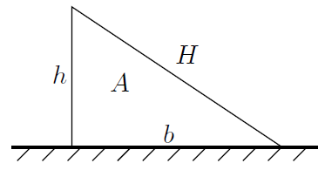

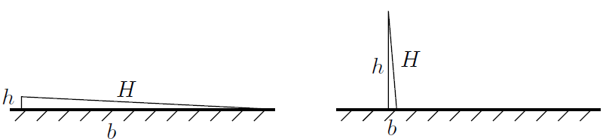

* Another optimization example

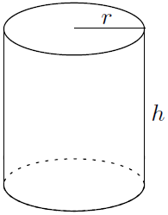

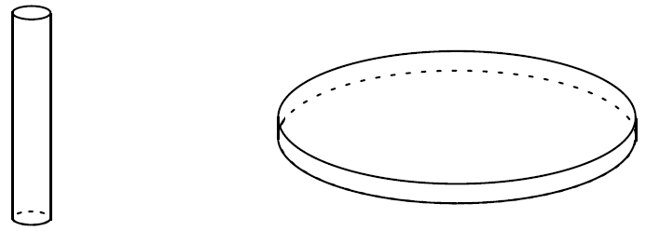

* Using implicit differentiation in optimization (Page 274)
* A difficult optimization example

1. Linearization

Now we're going to use the derivative to estimate certain quantities. For example, suppose you want to get a decent estimate of without using a calculator. We know that is a little bigger than , so you could certainly say that is approximately 3-and-a-bit. That's OK, but you can actually do a better job without too much work. Here's how it's done

Start off by setting for any . Inspired by our knowledge of when , let's sketch the graph of , and draw in the tangent line through the point , like this:

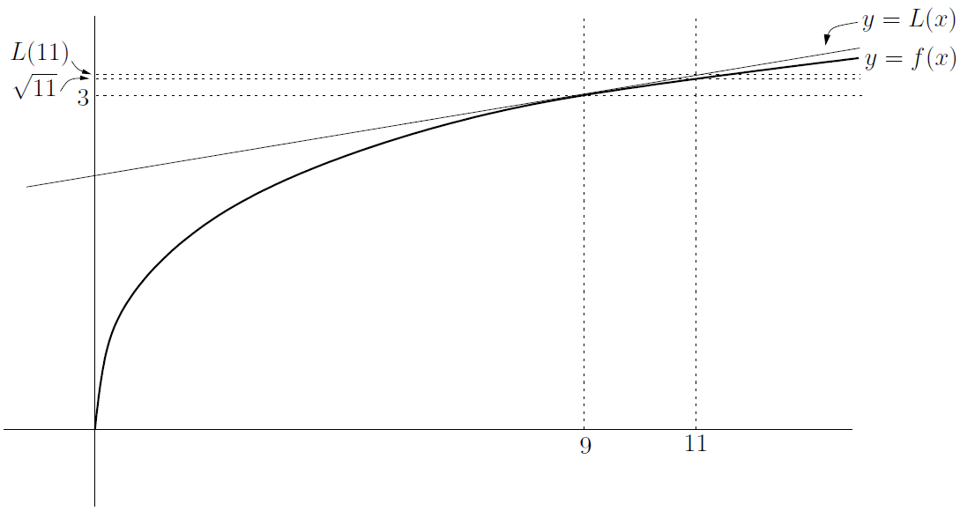

The linear function is . This means that the value of is a good approximation to . We get

We conclude that

That's a lot better than 3-and-a-bit! In fact, you can use a calculator to see that is (to three decimal places), so the approximation is pretty good

* Linearization in general

Let's generalize the above example. If you want to estimate some quantity, try to write it as for some nice function . Next, we pick some number , close to (what we’re interested in), such that is really nice. So, given our function and our special number , we find the tangent to the curve at the point . If the tangent line is , we get

The linear function is called the *linearization* of at . Remember, we're going to use as an approximation to . So we have

The benefit is that we now have an approximation for for **near**

* The differential

Let's take a look at the general situation once more. We saw that

Let's define to be , so that . The above formula becomes

Here's a graph of the situation:

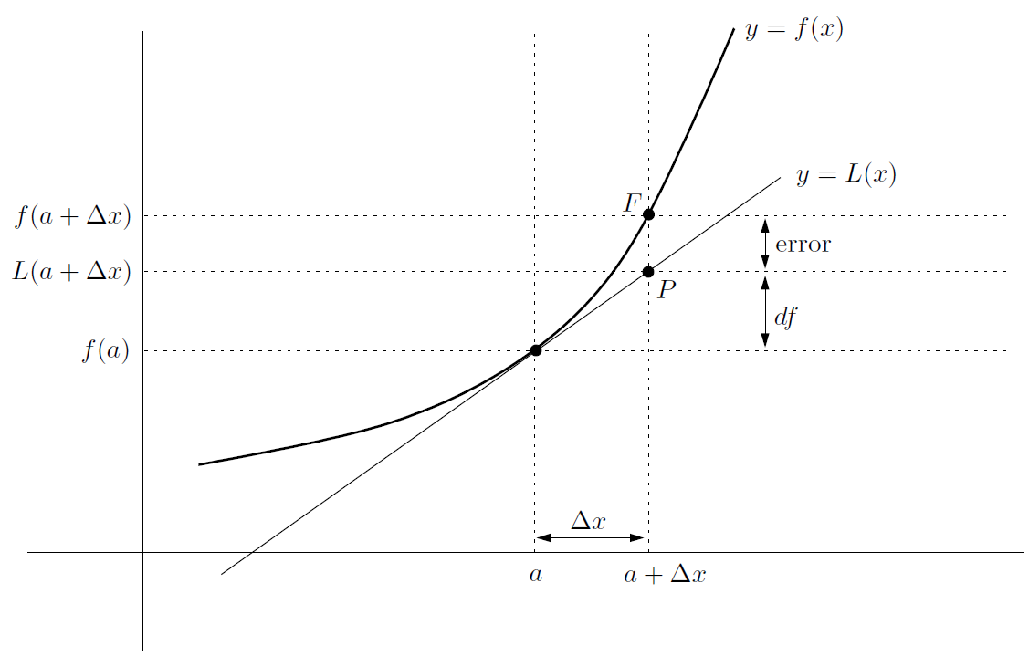

We want to estimate the value of . That's the height of the point in the above picture. As an approximate value, we're actually using , which is the height of in the picture. The difference between the two quantities is labeled “error”

In the above graph, there's one more quantity marked: this is , which is the difference between the height of and . It is the amount we needed to add to in order to get our estimate. Since , we see that

The quantity is called the *differential* of at . It is an approximation to the amount that changes when moves from to

We've actually touched on these ideas before: if , then

Here's an important example at page 282: a truth that when you compound the error in a one-dimensional measurement in the calculation of a three-dimensional quantity

* Linearization summary and examples

Here's the basic strategy for estimating, or approximating, a nasty number:

1. Write down the main formula
2. Choose a function , and a number such that the nasty number is equal to . Also, choose close to such that can easily be computed
3. Differentiate to find
4. In the above formula, replace and by the actual functions, and a by the actual number you've chosen
5. Finally, plug in the value of from step 2 above. Also note that the differential is the quantity

More generally an example, how would you find an approximation for , where is **any** small number? That is,

when is small. Actually, this shouldn't be a surprise! Since

* The error in our approximation

We've been using as an approximation for . They are not the same thing, though. How wrong could we be to use instead of ? The way to find out is to consider the difference between the two quantities:

where r(x) is the error in using the linearization at in order to estimate . It turns out that if the second derivative of exists, at least between and , then there's a nice formula (Page 285) for :

The problem is, we don't know what is, only that it's between and . The above formula is related to the Mean Value Theorem

In summary,

* if is **positive** between and , then using the linearization leads to an **underestimate**
* if is **negative** between and , then using the linearization leads to an **overestimate**

Now look back at the equation for the error above. If we take absolute values of both sides of the equation, then we get

Suppose we know that the biggest could be, as ranges between and , is some number . Then even though we don't know what is, we do know that , so we get the following formula:

1. Newton's Method

Here's another useful application of linearization. Suppose that you have an equation of the form that you'd like to solve, but you just can't solve the darned thing. So you do the next best thing: you take a guess at a solution, which you call . The situation might look something like this:

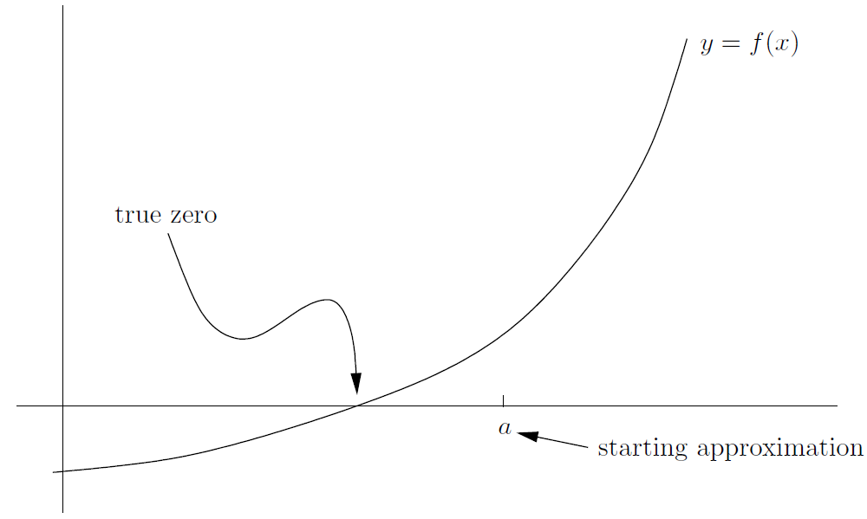

Think of as a first stab at an approximation, which is why it's labeled “starting approximation” in the picture above. Now, the idea of Newton's method is that you can (hopefully) improve upon your estimate by using the linearization of about . (This means that needs to be differentiable at , of course!)

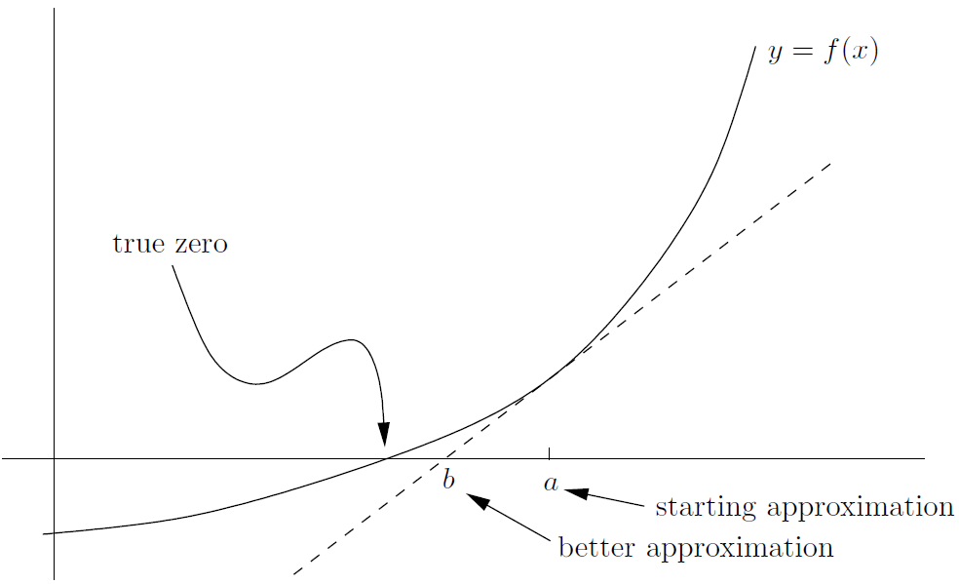

The -intercept of the linearization is labeled , and it's clearly a better approximation to the true zero than is. So what is the value of ? Well, it's just the -intercept of the linearization , which is given by

To find the -intercept, set ; then we get

So we have found the following formula:

**Newton’s method**: suppose that is an approximation

to a solution of . If you set

then a lot of the time is a better approximation than

It doesn't work all the time, so I put in the phrase “a lot of the time” to cover my ass

It might seem confusing to reuse and like this. A way around it is to use as the initial guess and as the first improvement; then is the second improvement, starting with ; and so on. The formula can now be written like this:

Sometimes Newton's method doesn't work. Here are four different things that could go wrong:

1. **The** value **of could be near** . Clearly, if

then can't be or else isn't even defined. Even if is close, but not equal to , Newton's method can still give a whacked-out result; for example, check out this picture:

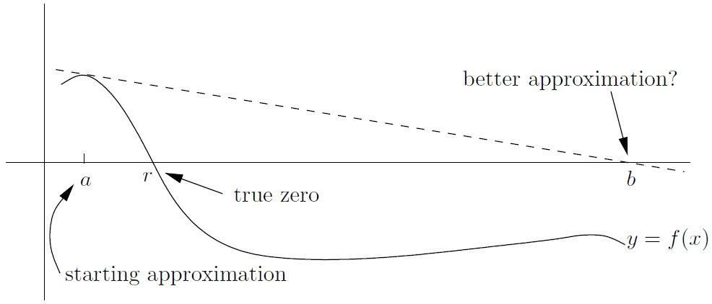

To get around this, make sure that your initial approximation is not near a critical point of your function

1. **If has more than one solution, you might not get the right one**. For example, in the following picture, if you are trying to estimate the left-hand root , and you guess to start at , you'll end up estimating instead:

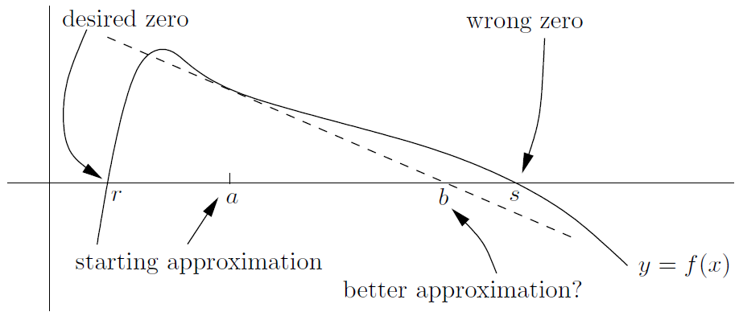

So you should make some effort to start with an estimate which is close to the zero you want, unless you're sure there's only one zero!

1. **The** **approximations might get worse and worse**. For example, if , the only solution to the equation is . If you try to use Newton's method (for reasons best known to yourself, I guess!), then something weird happens. You see, unless you start with , this is what you find:

So the next approximation is always times the one you started with. These would be just getting farther and farther away from the correct value . There's not much you can do with Newton's method if this sort of thing happens

1. **You might get stuck in a loop**. It's possible that your estimate leads to another estimate , which then leads back to again. Here's how the situation might look:

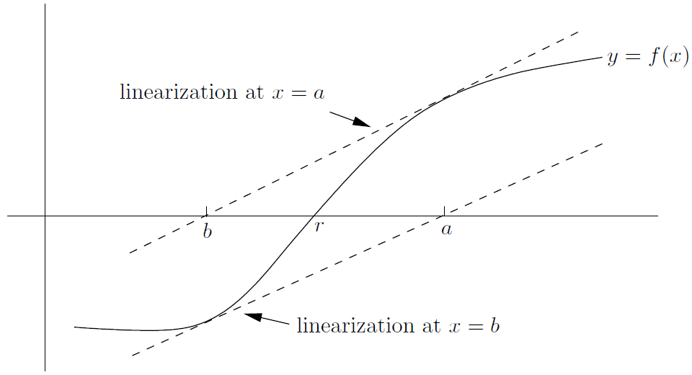

The linearization at has -intercept , and the linearization at has -intercept , so Newton's method just doesn't work. A concrete (but messy) example is

(By the way, the study of these sorts of loops leads to a nice type of fractal that you might have seen as a screensaver on someone's computer. . . .)

**CHAPTER 14 L'Hôbpital's Rule and Overview of Limits**



We've used limits to find derivatives. Now we'll turn things upside-down and use derivatives to find limits, by way of a nice technique called l'Hôpital's Rule

1. L'Hôbpital's Rule